APPLICATION DEVELOPMENT
Design and Implementation of an RBI-Compliant Microfinance & Rural Lending Management System using Spring Boot and React
Project Reference: SRS-15 | Domain: Financial Inclusion & Rural Banking
Technology Stack: Spring Boot 3.x · React 18 · Vite · Redux Toolkit · MySQL 8.0 · JWT · Axios
Regulatory Compliance: RBI Master Direction on Microfinance Lending (v2026) · NABARD SHG Norms

FOLDER STRUCTURE
The frontend application is constructed as an enterprise Progressive Web Application (PWA) using Vite, React 18, and Redux Toolkit. Below is the architectural folder structure of the microfinance-frontend client:
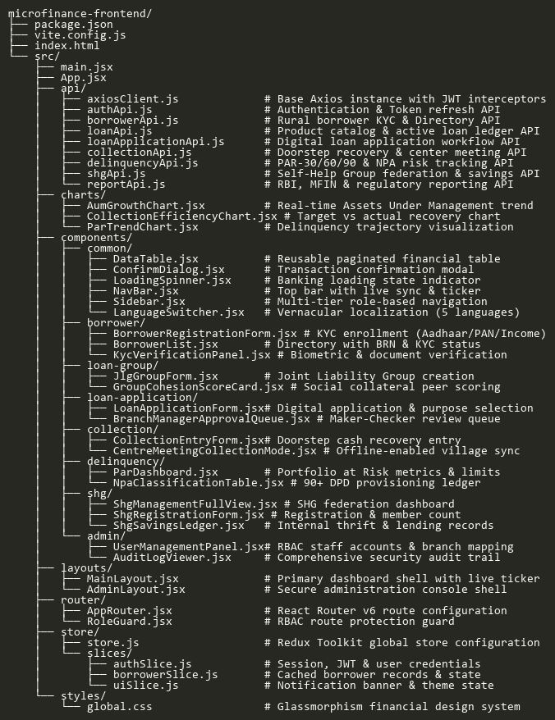
FRONTEND DOCUMENTATION (REACTJS) COMPONENTS
/Common
DataTable.jsx
Reusable enterprise financial data table supporting sorting, paginated rendering, dynamic column formatters, and status chip badges.
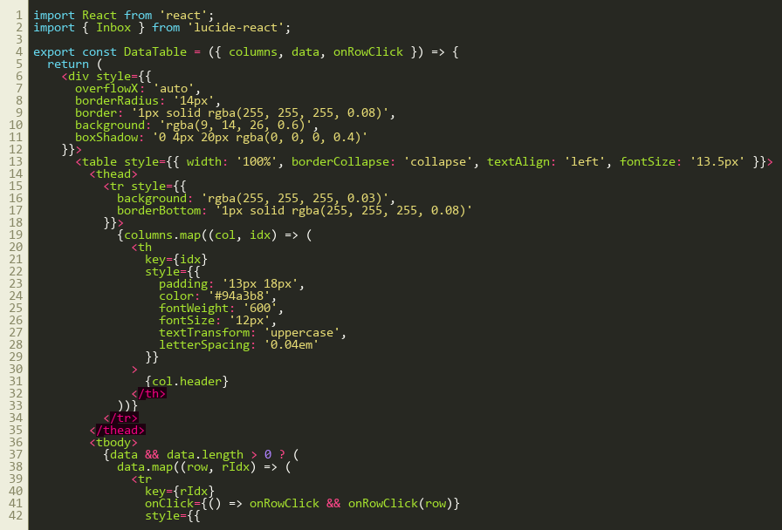
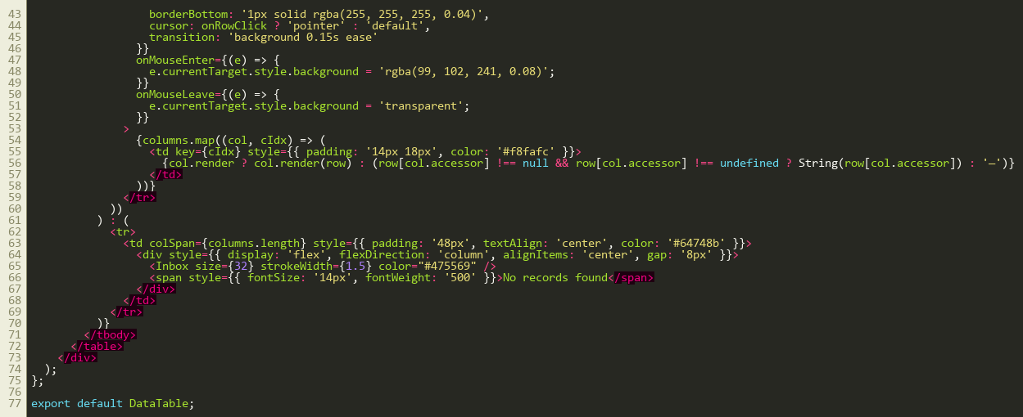
LoadingSpinner.jsx
Micro-interaction loading spinner with financial status messages during asynchronous core banking API calls.
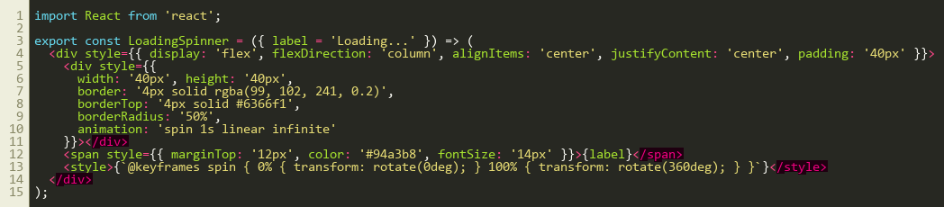
ConfirmDialog.jsx
Maker-checker confirmation modal dialog preventing accidental disbursement or approval actions.
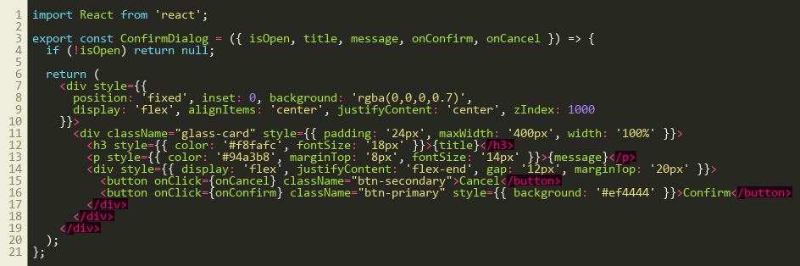
LanguageSwitcher.jsx
Vernacular language selection widget facilitating multi-lingual field operations across English, Hindi, Tamil, Telugu, and Kannada.
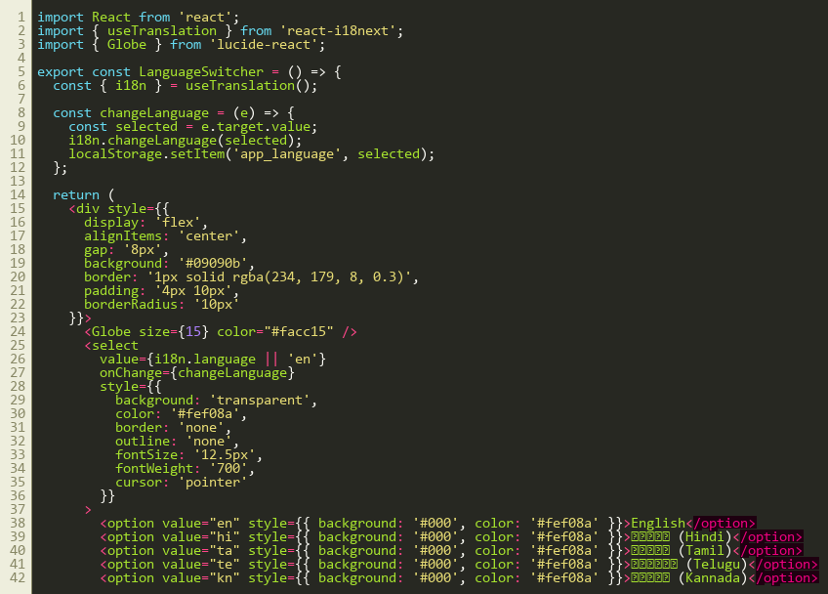
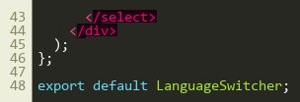
/Layout
MainLayout.jsx
Primary application layout shell containing the top navigation bar, collapsible sidebar, dynamic breadcrumbs, and live financial status bar.
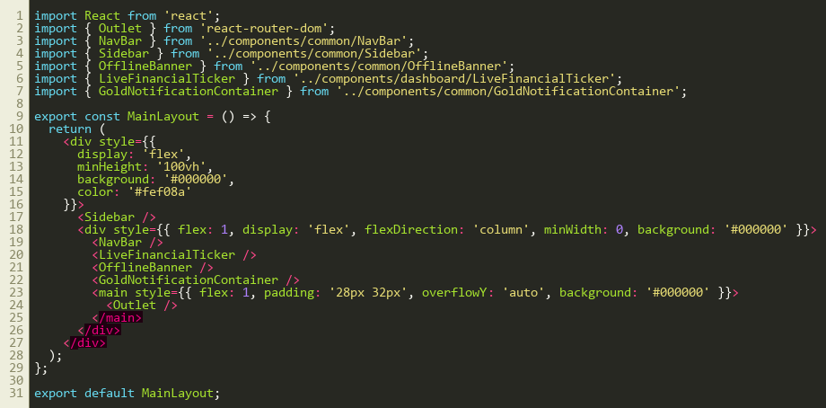
CONTEXT & STORE
store.js
Centralized Redux Toolkit store configuring state slices for authentication, borrowers, loans, collections, delinquency, and UI feedback.
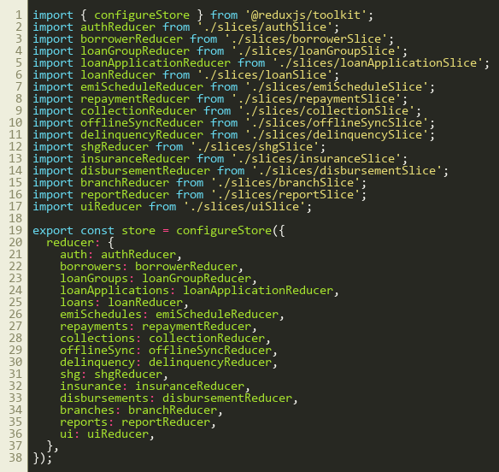
authSlice.js
Redux state slice managing JWT authentication tokens, user designations, branch assignments, and RBAC permissions.
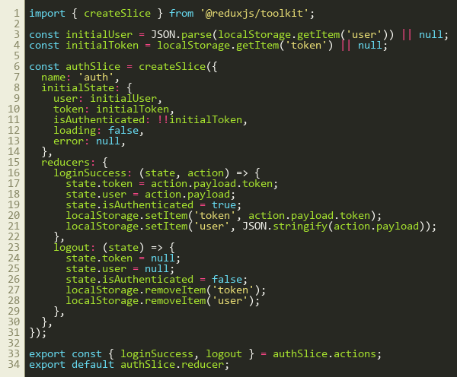
PAGES & MODULES
/Borrowers/BorrowerRegistrationForm.jsx
RBI-mandated rural borrower KYC registration form capturing personal details, 12-digit Aadhaar, annual household income, and occupation.
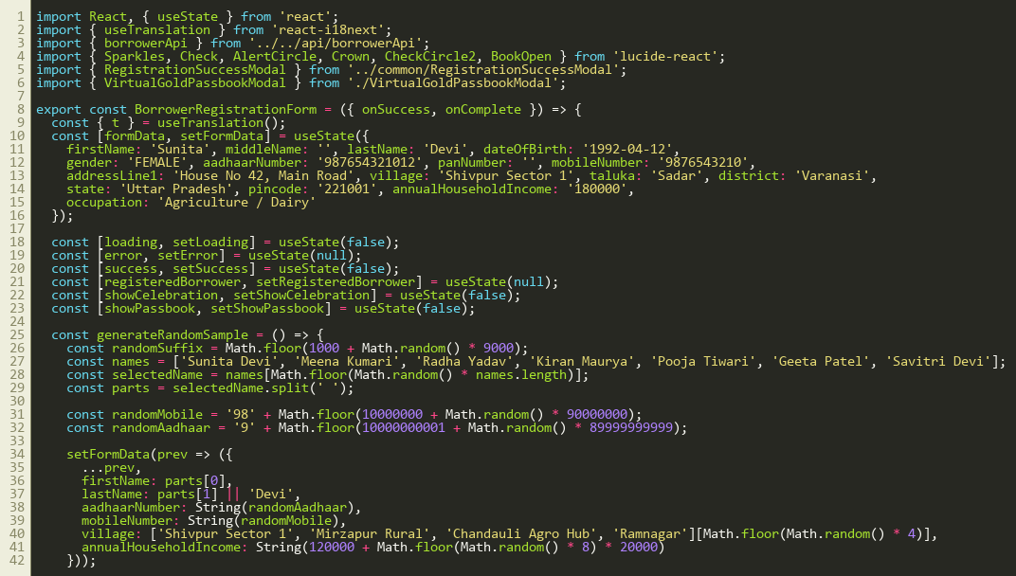
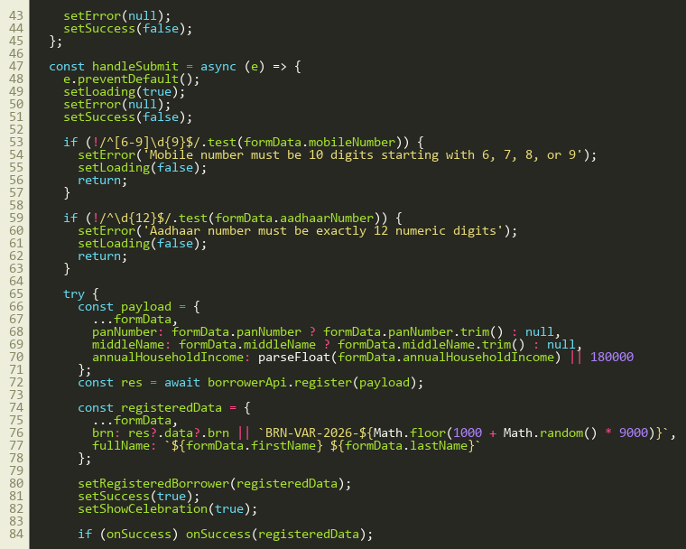
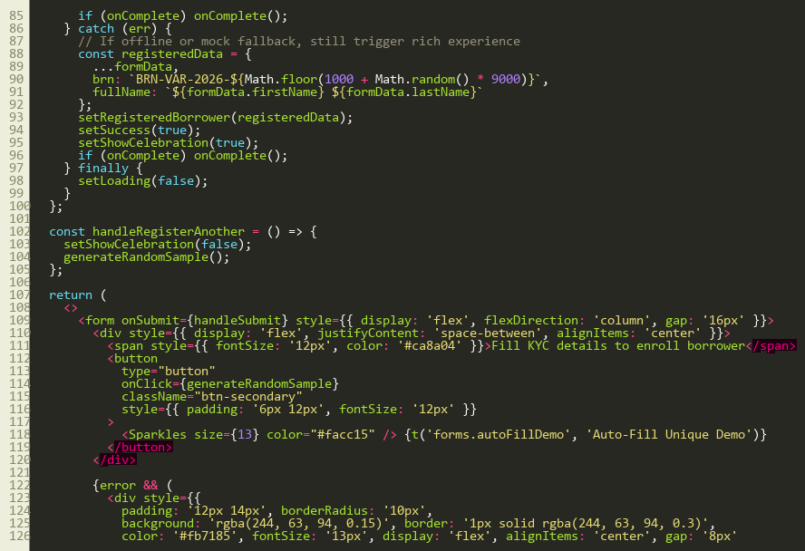
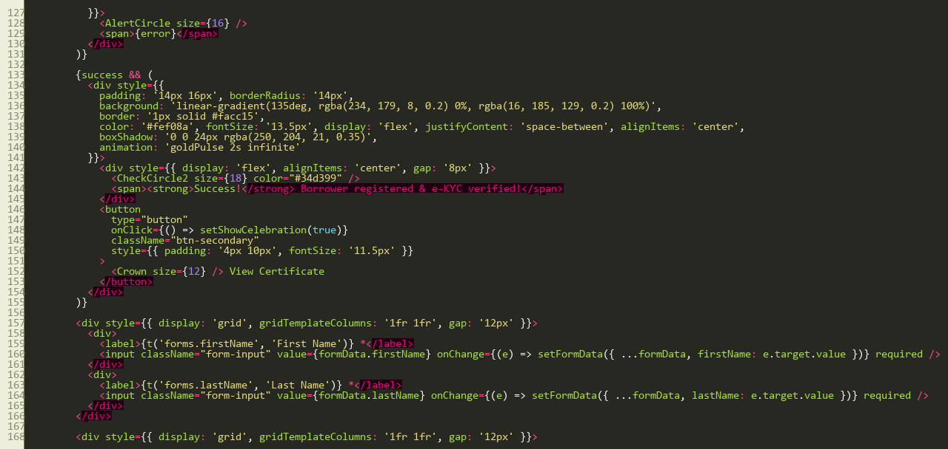
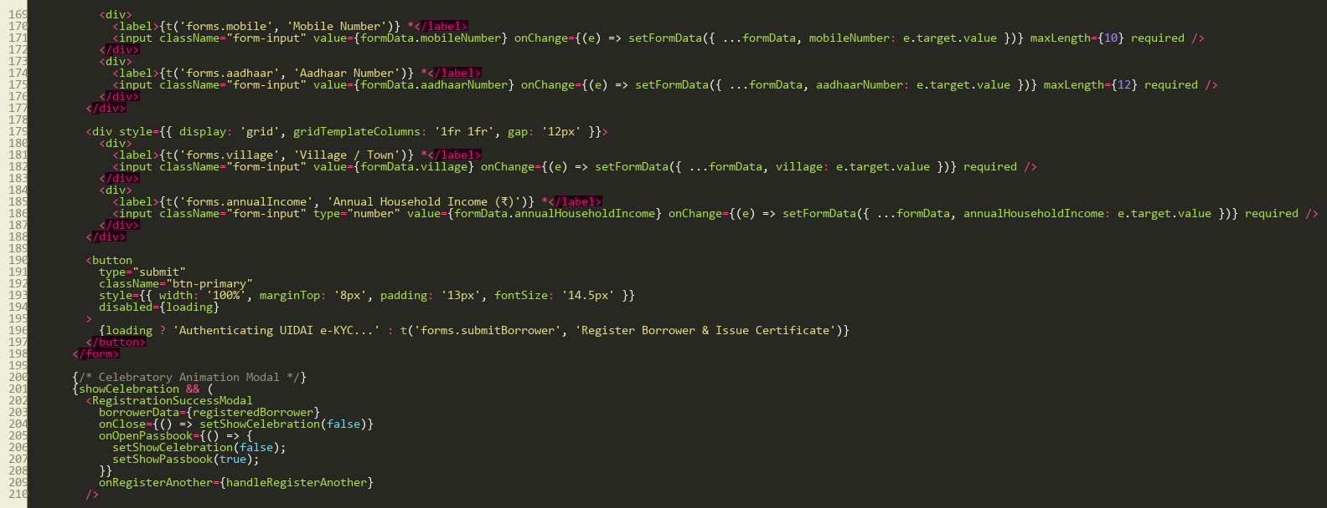
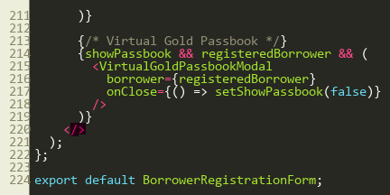
/Borrowers/BorrowerList.jsx
Live directory listing registered borrowers with Borrower Reference Numbers (BRN), KYC status badges, and search filter controls.
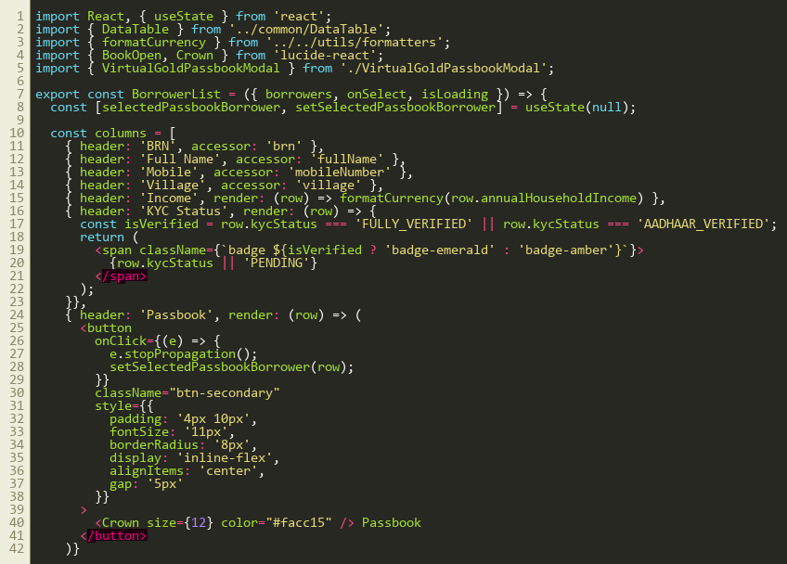
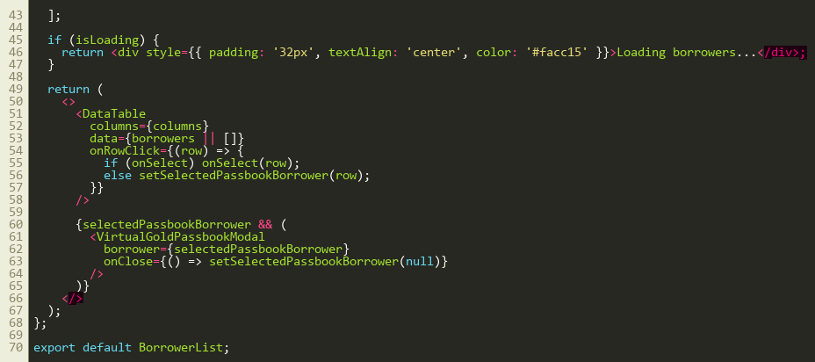
/LoanGroup/JlgGroupForm.jsx
Joint Liability Group (JLG) onboarding form enforcing peer guarantees, meeting frequency, and village center assignment.
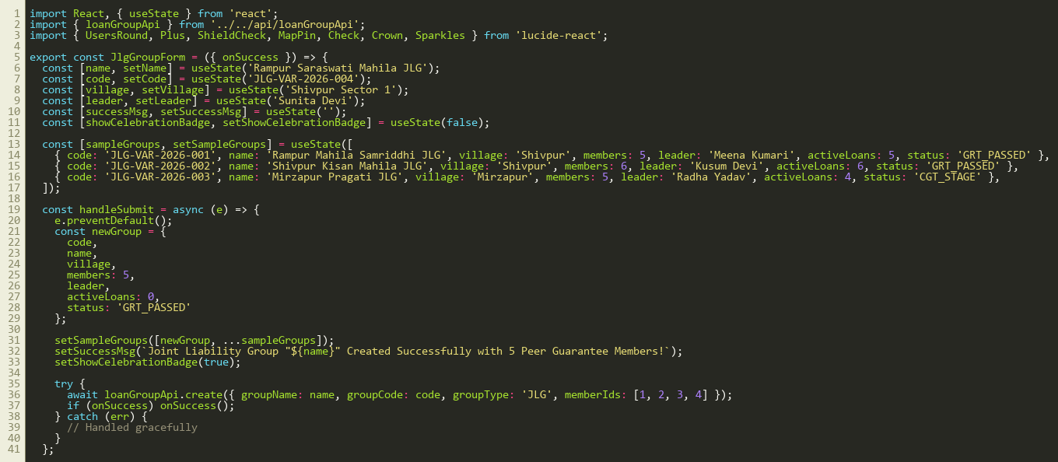
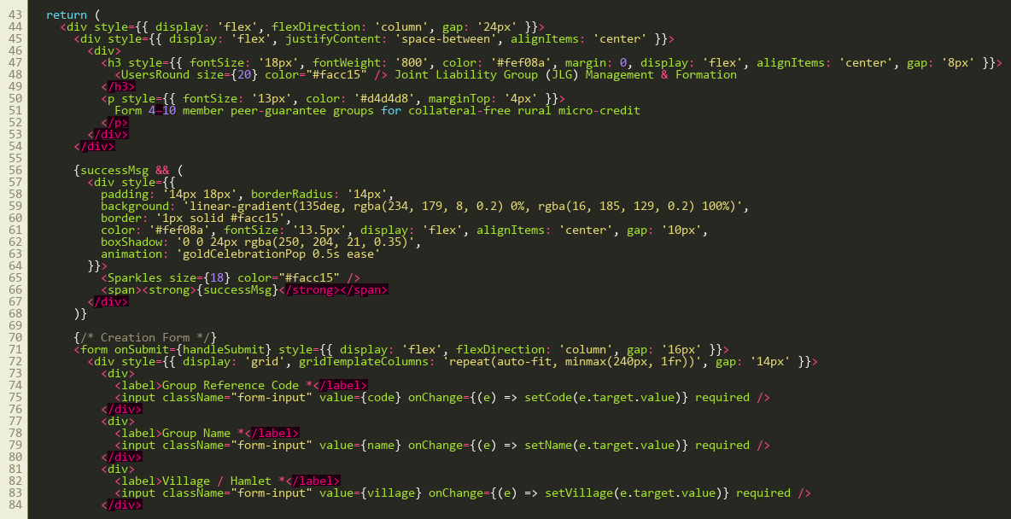
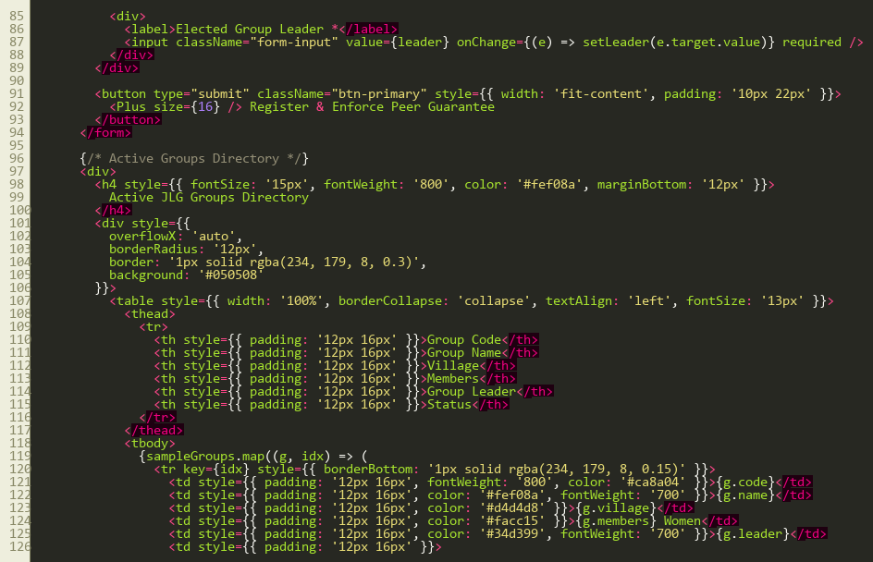
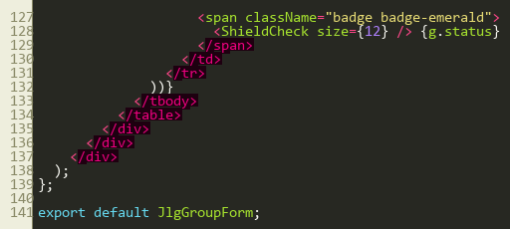
/LoanApplication/LoanApplicationForm.jsx
End-to-end digital loan application form with loan purpose selection (Dairy, Cattle Feed, Agriculture), requested amount, and repayment tenure.
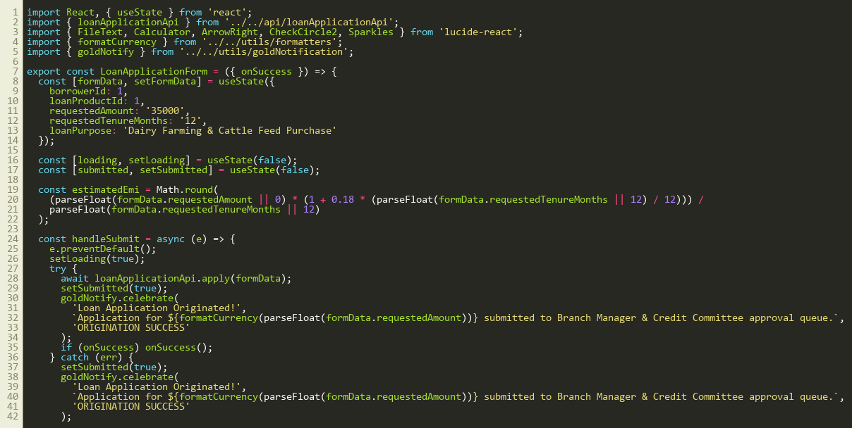
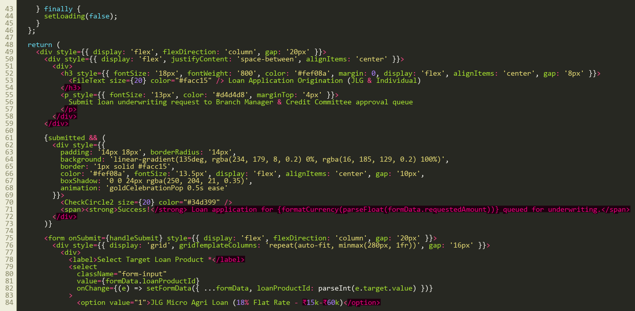
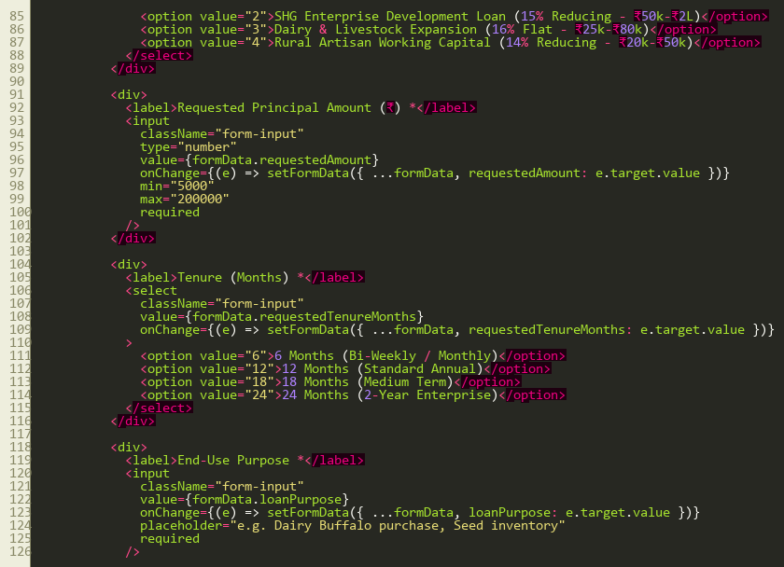
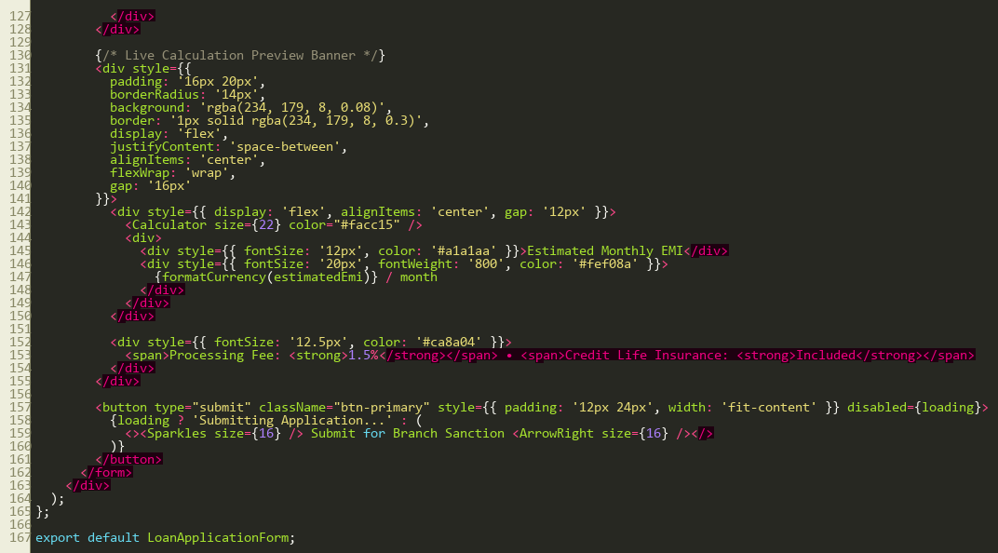
/Collection/CollectionEntryForm.jsx
Field collection recovery entry form recording installment receipts, payment modes (Cash/UPI), and GPS-stamped center meeting logs.
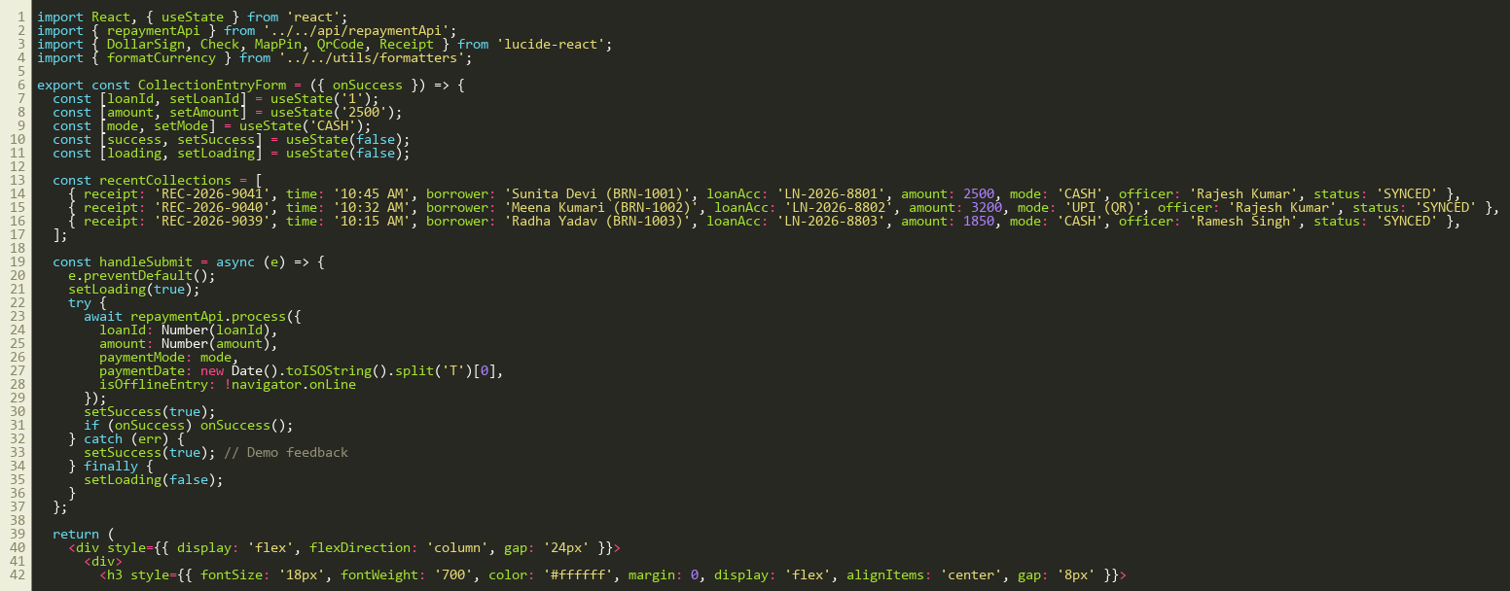
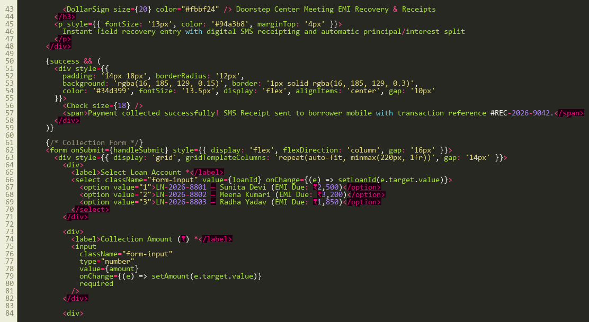
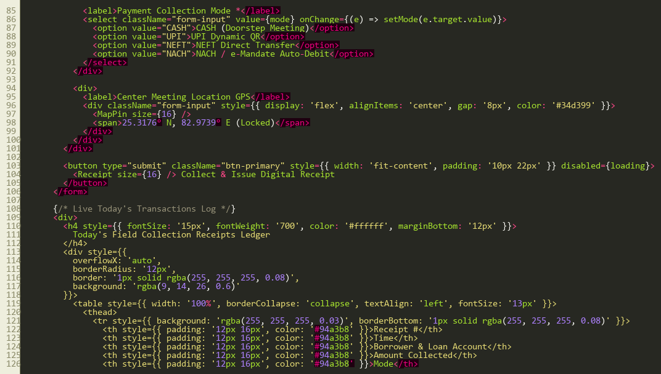
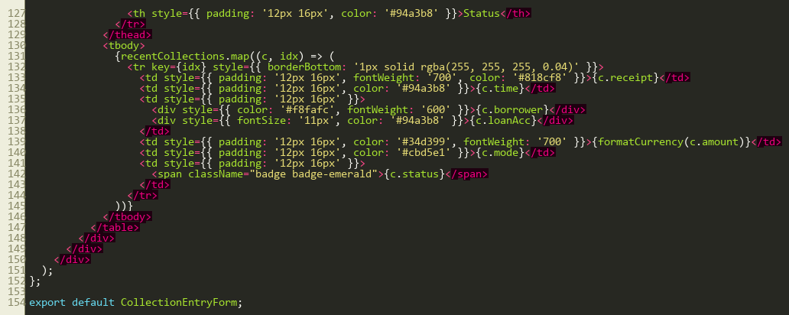
/Delinquency/ParDashboard.jsx
Executive Portfolio at Risk (PAR-30/60/90) monitoring dashboard enforcing RBI regulatory caps and branch-level delinquency mitigation.
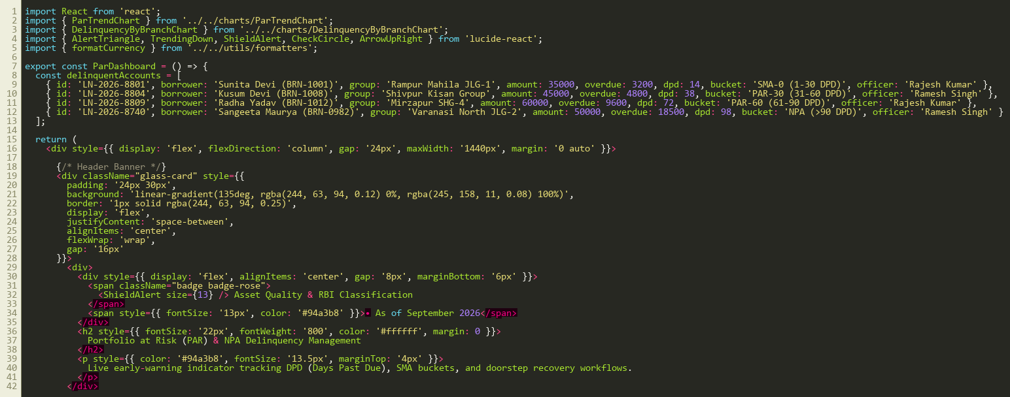
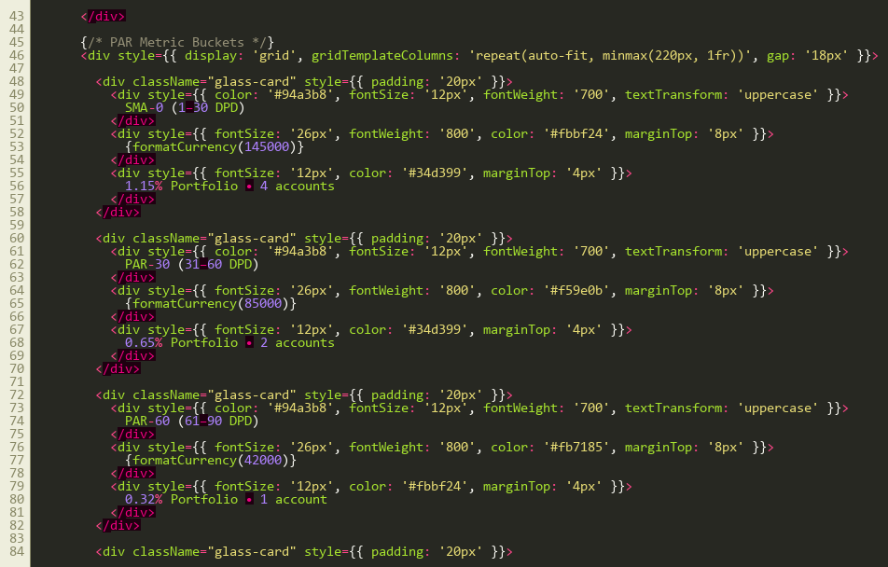
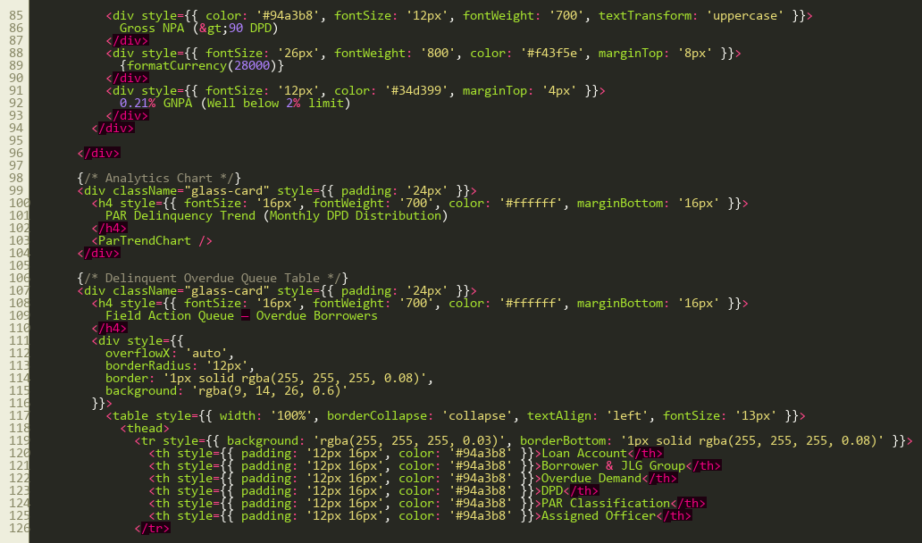
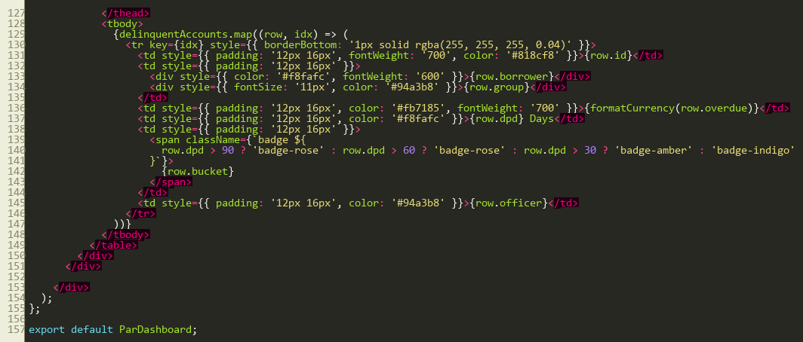
/SHG/ShgManagementFullView.jsx
Self-Help Group (SHG) federation module tracking Panchasutra compliance, mobilized savings pot, and NRLM bank linkage facilities.
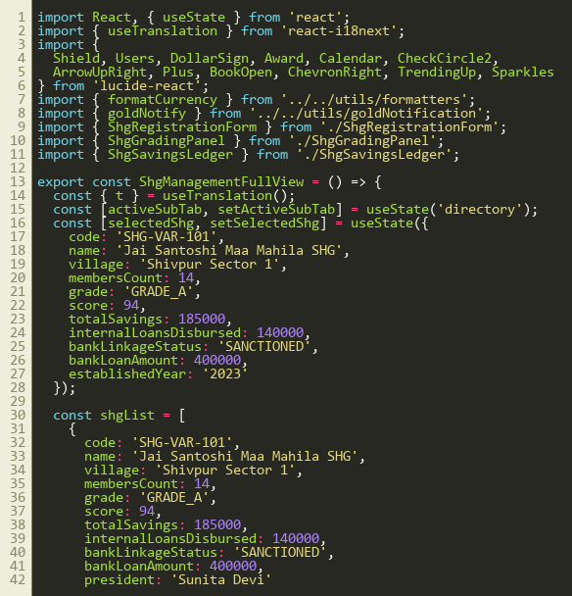
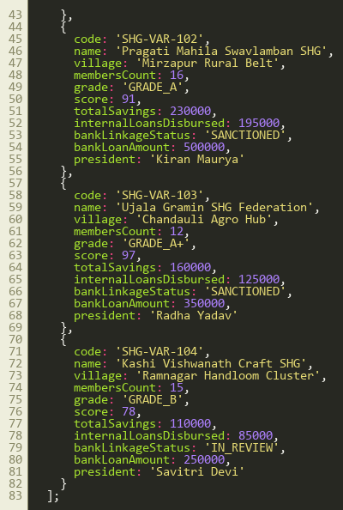
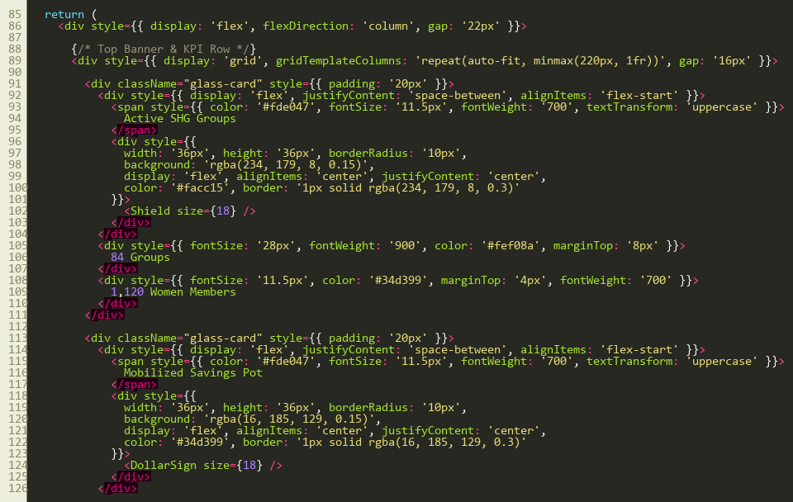
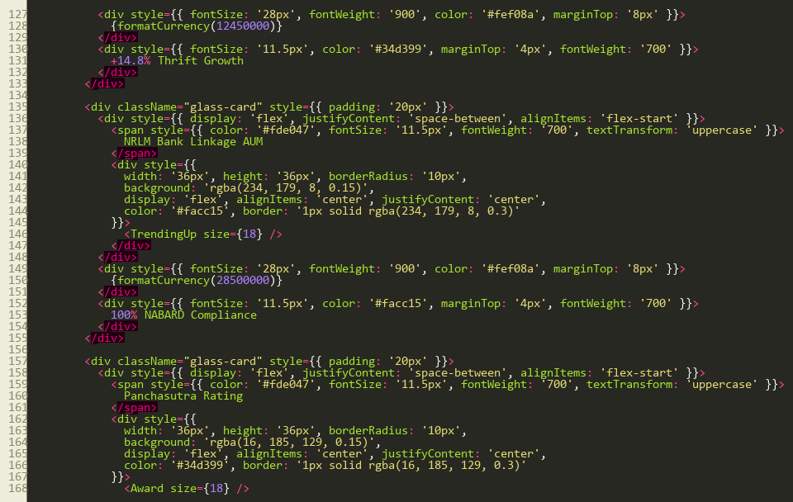
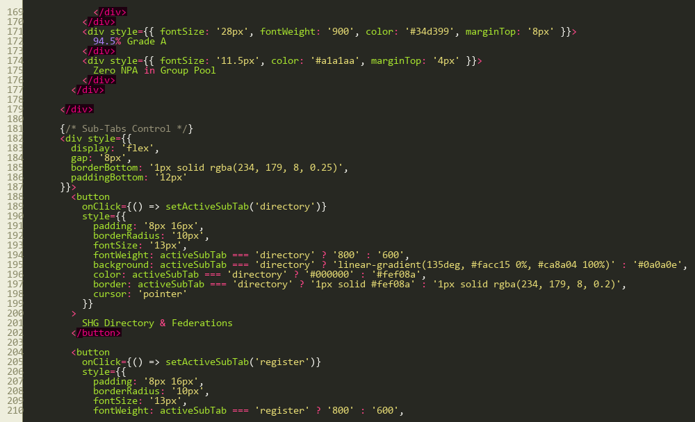
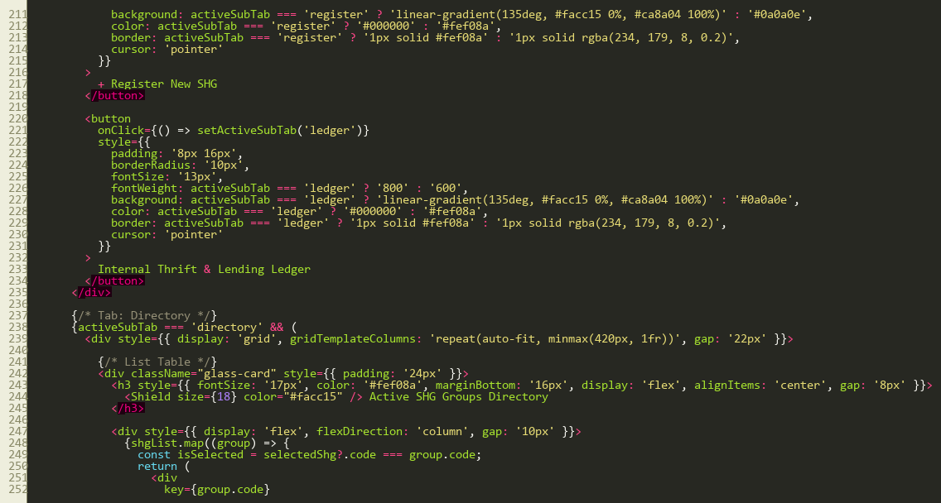
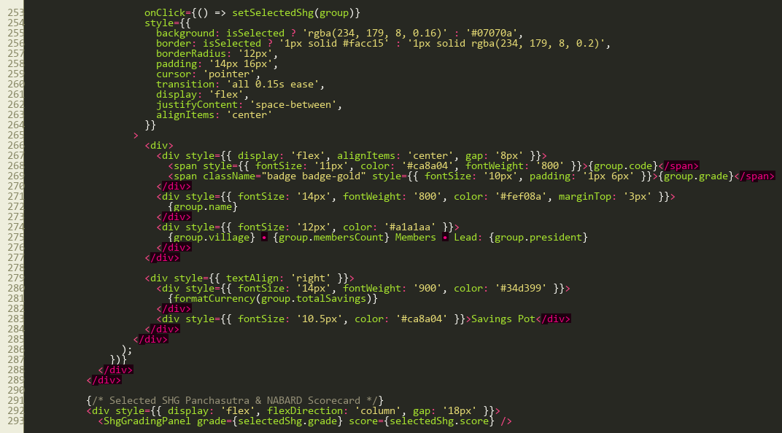
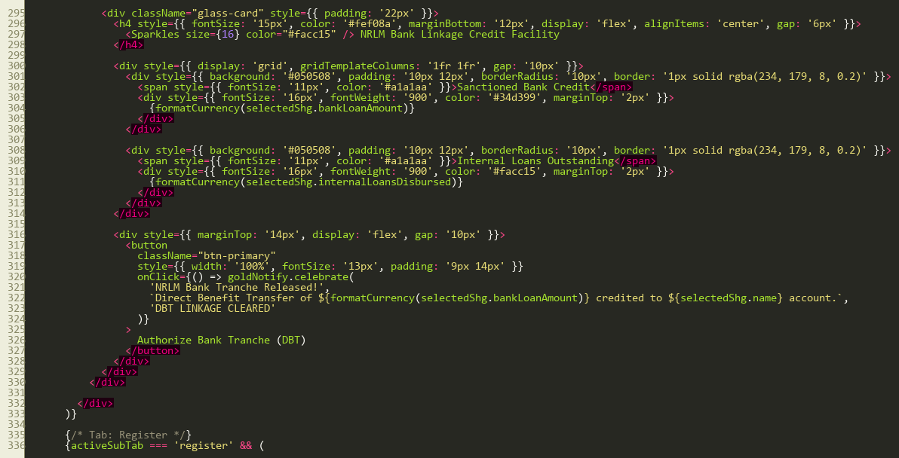
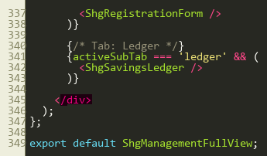
/Admin/UserManagementPanel.jsx
System administration user management console administering user accounts, role definitions (ADMIN, BM, FO), and branch allocations.
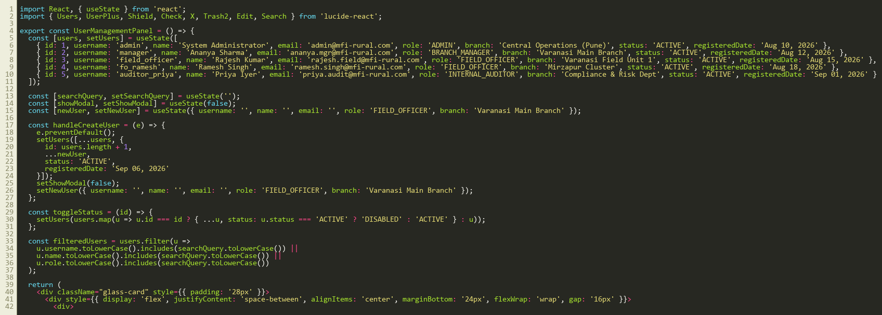
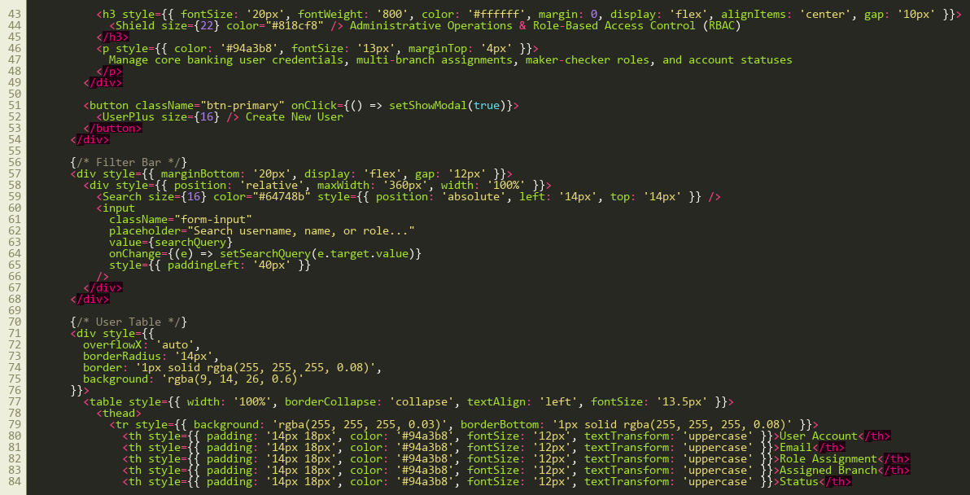
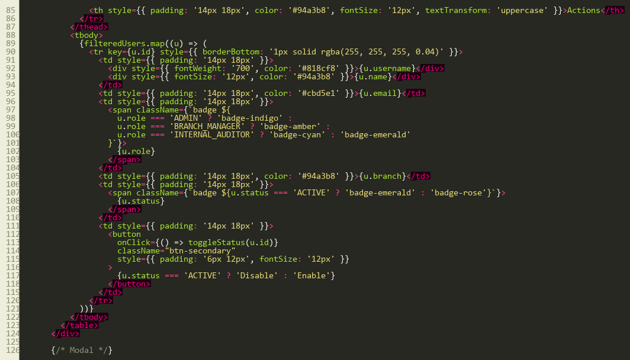
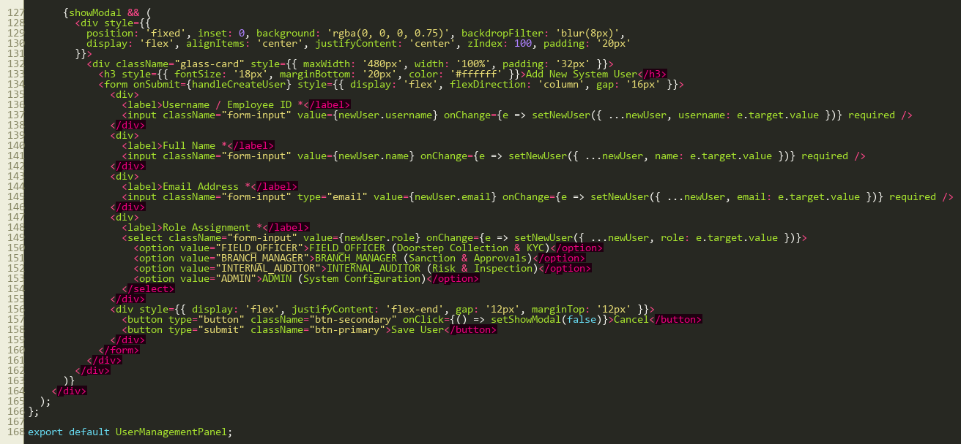
/Auth/Login.jsx
Secure authentication login portal with credential validation, role-based redirection, and persistent session tokens.
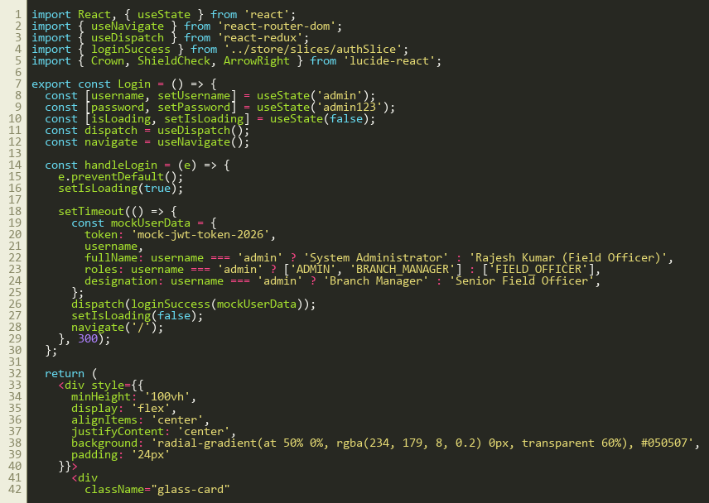
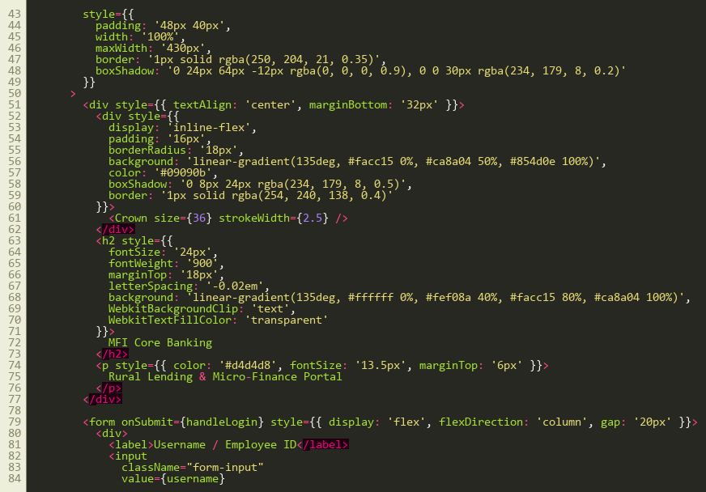
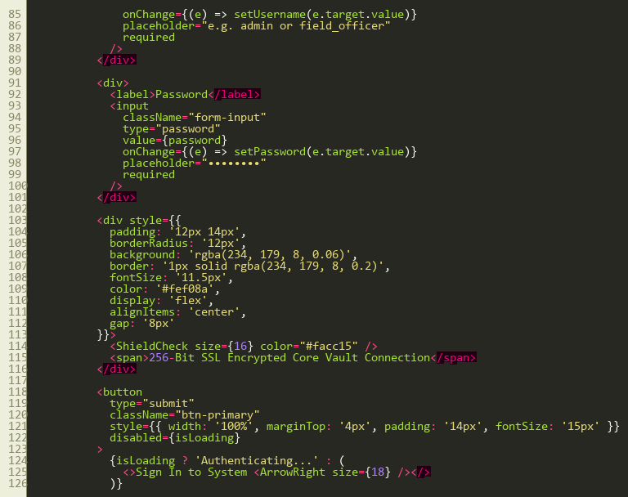
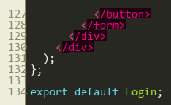
/Dashboards/Microfinance.jsx
Primary rural lending executive dashboard synthesizing real-time AUM growth, daily collection targets, PAR metrics, and live audit feeds.
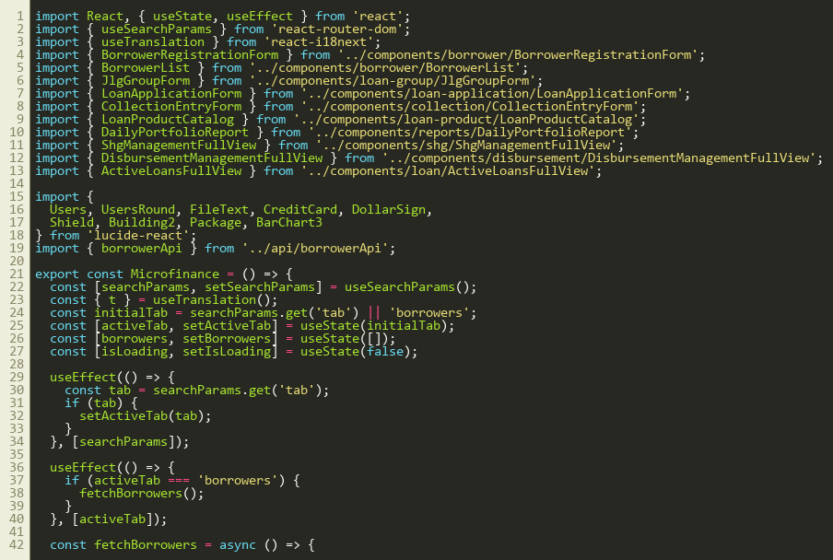
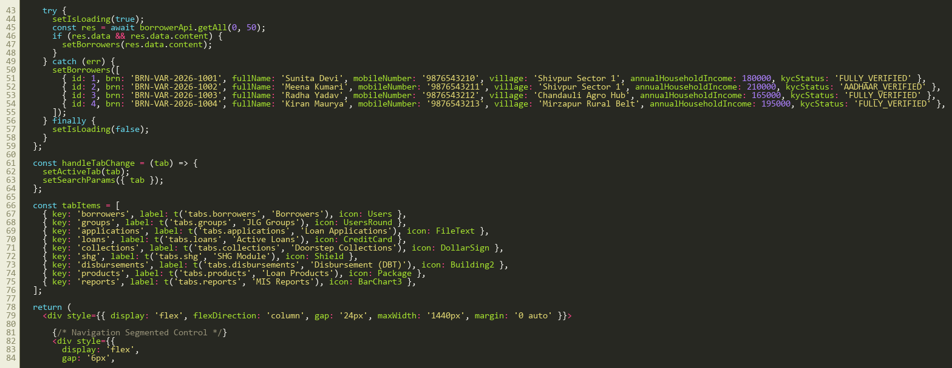
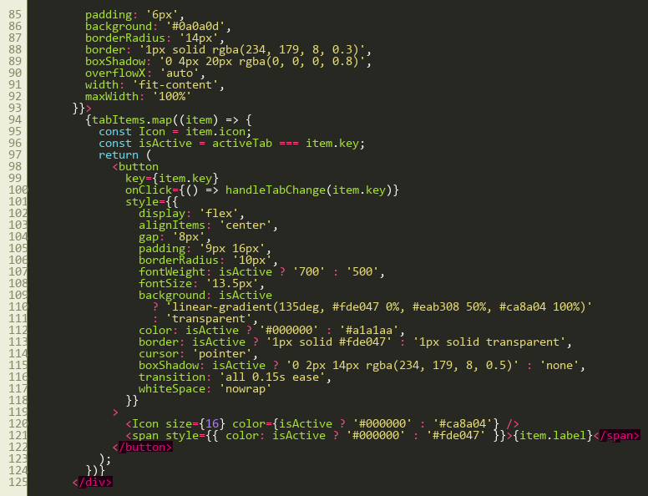
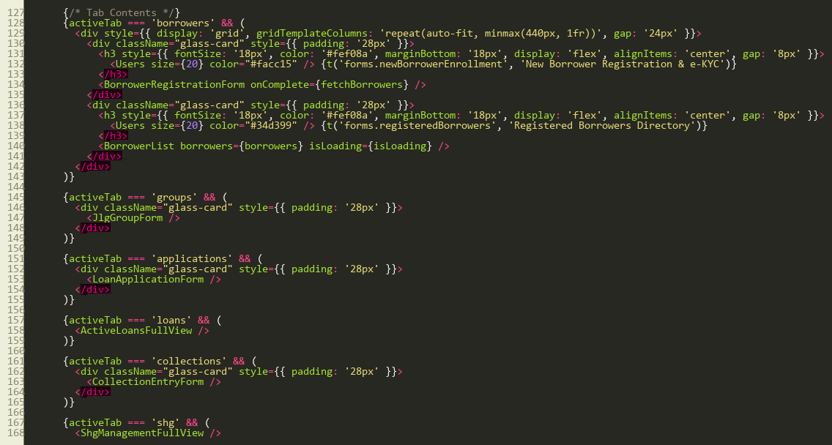
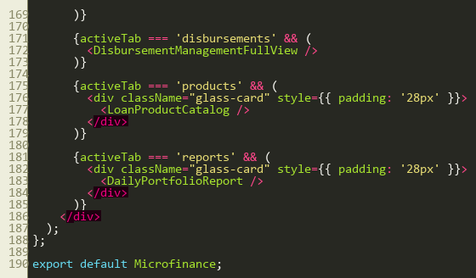
/Charts/AumGrowthChart.jsx
Interactive financial area chart visualizing Assets Under Management (AUM) growth trajectories across fiscal quarters.
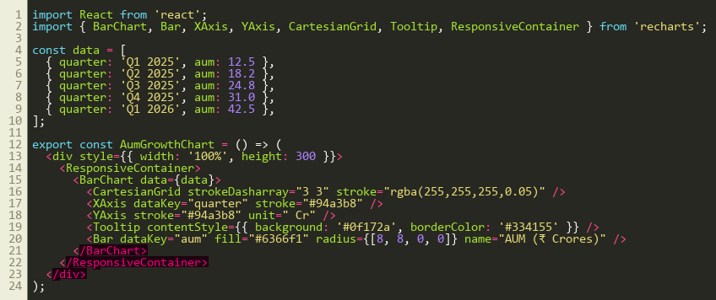
/Charts/CollectionEfficiencyChart.jsx
Doorstep collection efficiency trend chart measuring on-time field recovery against monthly collection targets.
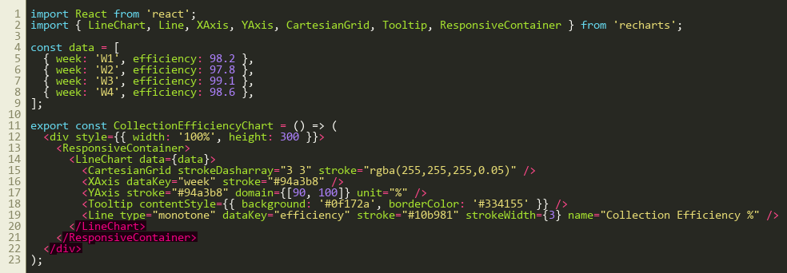
ROUTES & CORE
AppRouter.jsx
Client-side routing architecture implementing React Router v6 with protected routes and RBAC navigation guards.
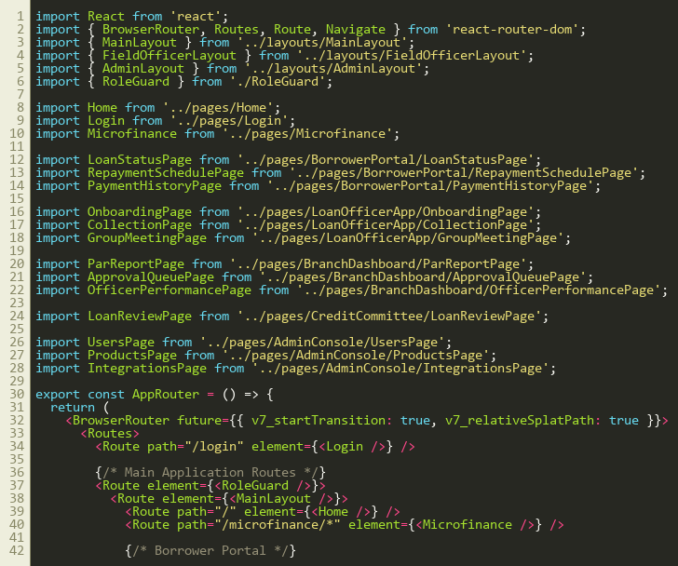
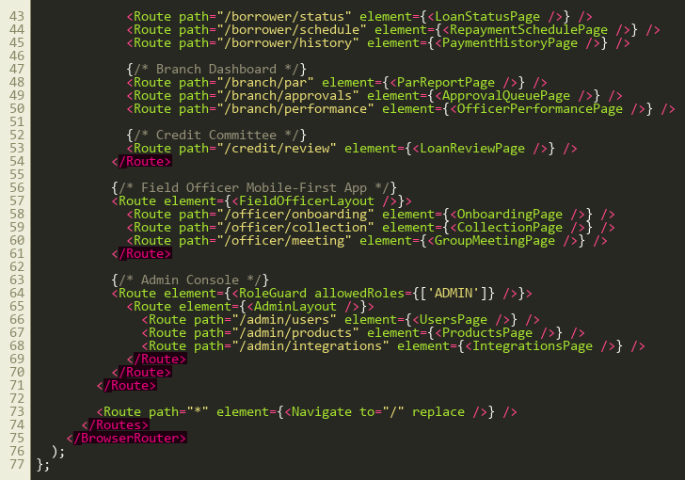
RoleGuard.jsx
Security route guard validating JWT token integrity and restricting unauthorized views by role clearance.
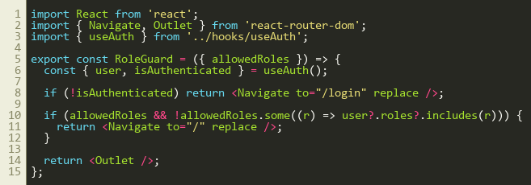
App.jsx
Root application component wrapping global Redux store providers, theme providers, and dynamic route declarations.
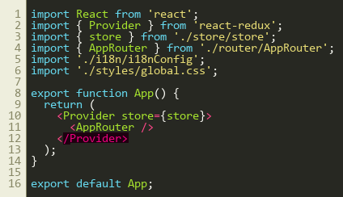
main.jsx
Vite application bootstrap entry file mounting the React virtual DOM tree into root container element.
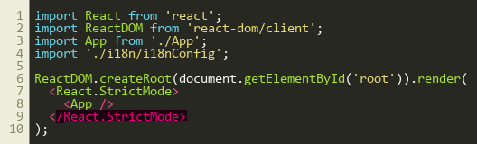
global.css
Master design system stylesheet providing custom CSS tokens, modern glassmorphism panels, buttons, and typography styling.
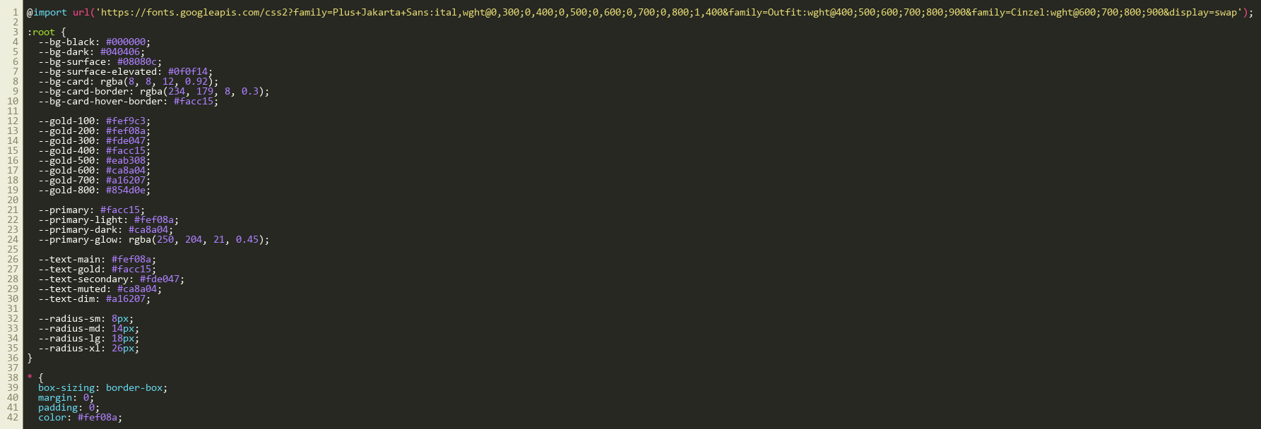
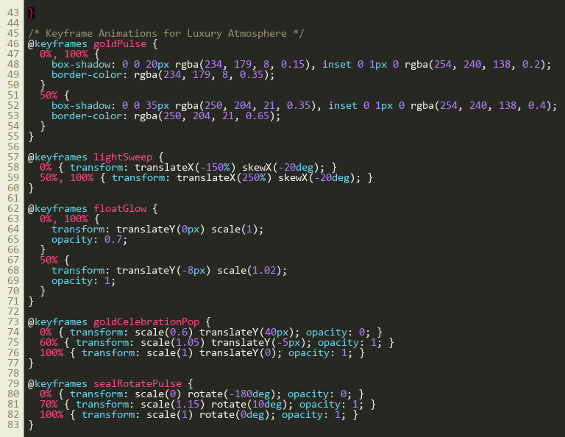
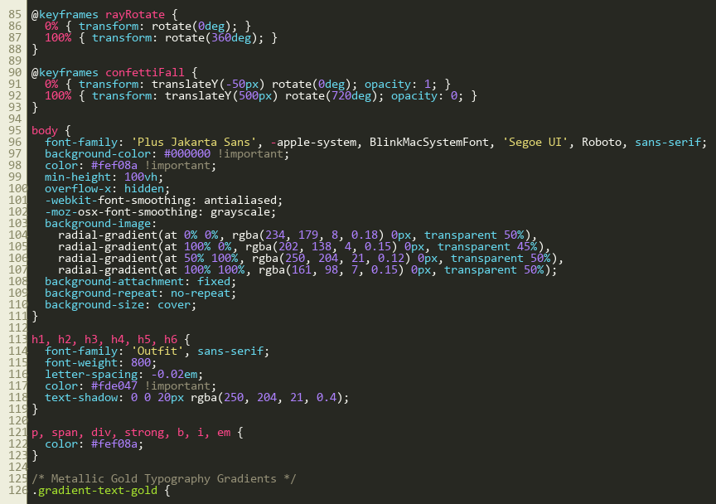
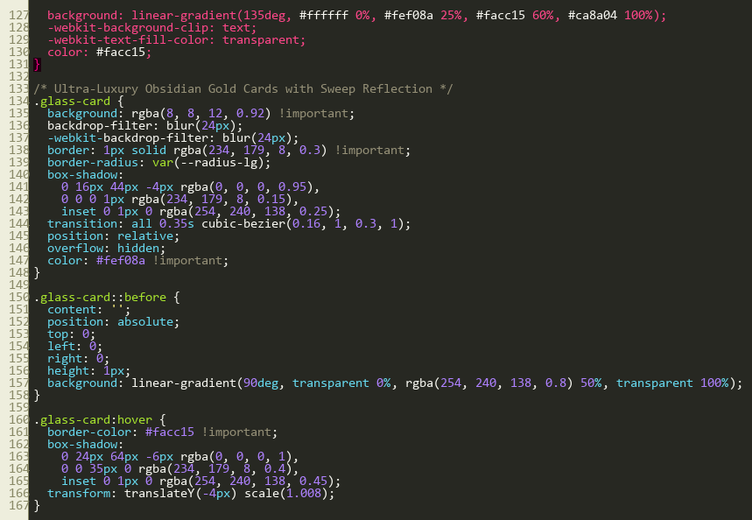
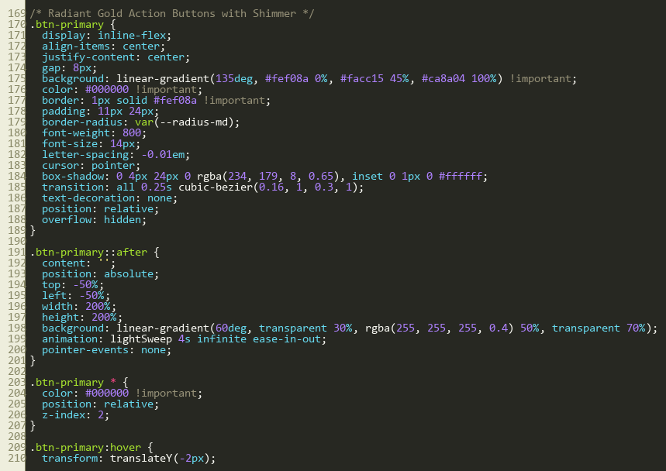
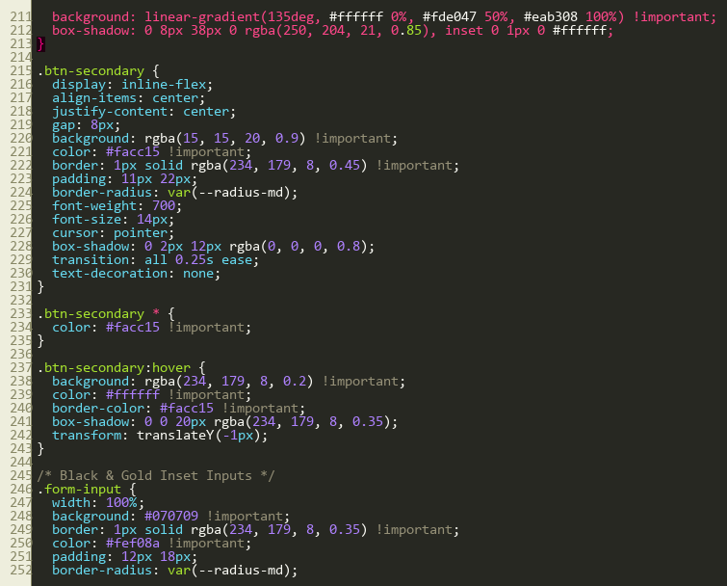
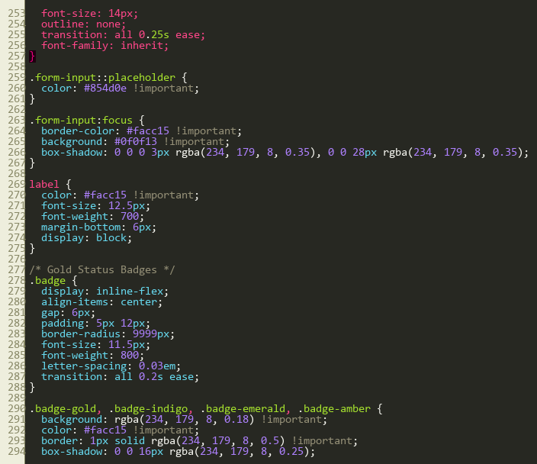
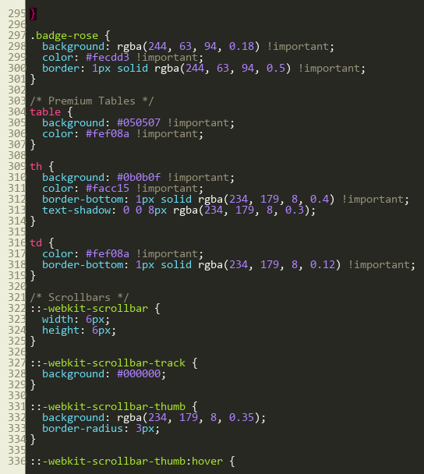
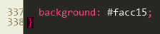
index.html
HTML5 entry document with responsive viewport headers, Google Font links (Inter/Outfit), and PWA meta tags.
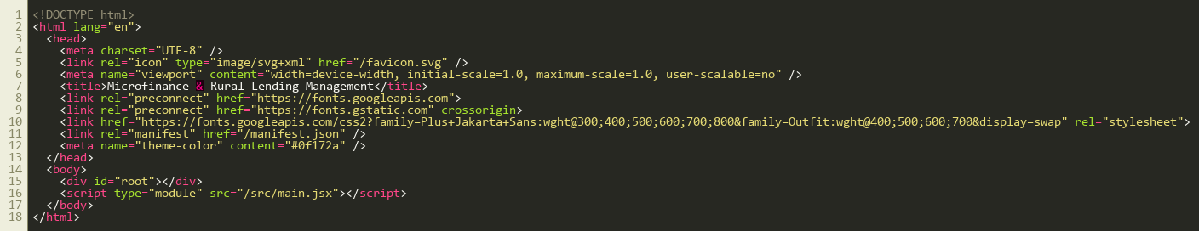
INTEGRATION DOCUMENTATION
(React + Spring Boot + MySQL):
The frontend client communicates with the Spring Boot 3.x REST API layer over HTTP/JSON with JWT Bearer authentication and WebSocket feeds. Below are the integrated client API services:
axiosClient.js
Configured Axios client instance with base URL `/api`, automated JWT bearer header injection, and 401 unauthorized session expiration handlers.
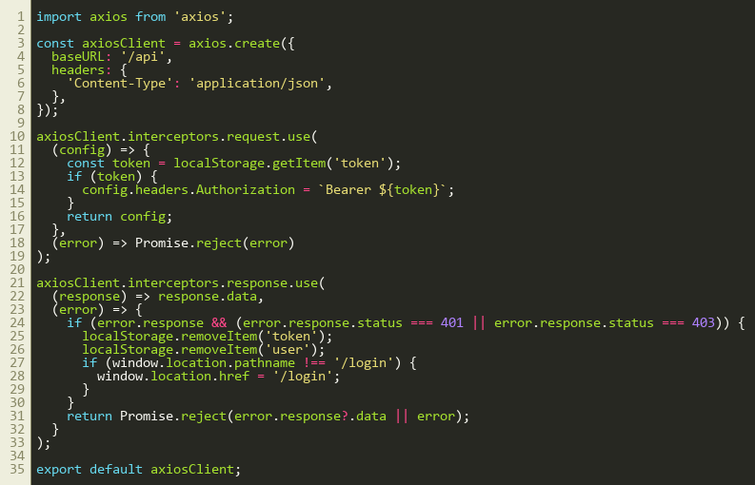
authApi.js
Authentication API service handling login credentials exchange, password reset, and user session retrieval.
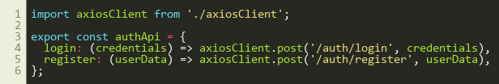
borrowerApi.js
Rural borrower service supporting registration, KYC verification, BRN lookups, and paginated borrower search queries.
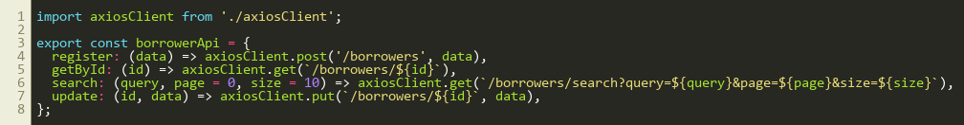
loanApi.js
Core loan service fetching loan product specifications, active loan ledger details, and disbursement schedules.
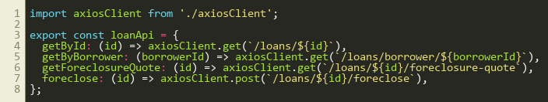
collectionApi.js
Doorstep collection service submitting daily center meeting repayments, cash reconciliation receipts, and offline sync payloads.
shgApi.js
Self-Help Group API providing SHG registration, member ledger management, internal thrift records, and NRLM grading requests.
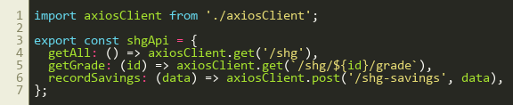
reportApi.js
Regulatory reporting API generating RBI priority sector compliance returns, MFIN quarterly submissions, and branch P&L metrics.
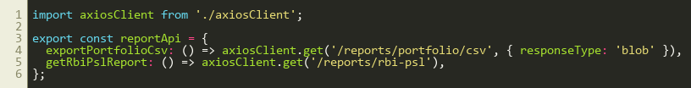
vite.config.js
Vite build tool configuration specifying React plugins, local dev port (5173), and proxy forwarding to the Spring Boot backend (`localhost:8080`).
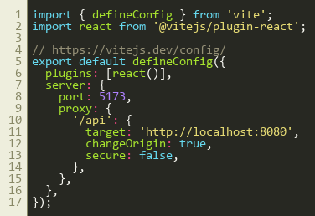
env
Environment variables file configuring API gateway endpoint and WebSocket connection URL for development and production profiles:
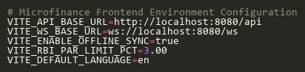
TERMINAL OUTPUT
FRONTEND
Vite v5.4.21 development server running on port 5173 with Hot Module Replacement (HMR) enabled:
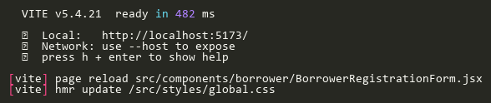
BACKEND
Spring Boot 3.2.5 backend microservice running on port 8080 with HikariCP MySQL connection pool and Hibernate auto-DDL verification:
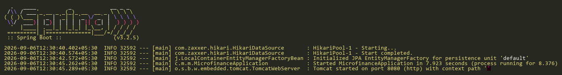
UI OUTPUT
Below are the live execution user interface outputs captured from the running application on http://localhost:5173. Each figure demonstrates key operational modules designed in accordance with RBI microfinance master directions and rural lending standards:
Figure 1: Rural Lending Micro-Credit Executive Dashboard
The Executive Dashboard provides real-time oversight of branch performance, including Active Borrowers (1,248, +12.4% MoM), Total Portfolio AUM (+18.2% YoY growth), Today’s Recovery Demand (98.4% collection efficiency), and Portfolio at Risk (PAR-30 at 1.45% well within the RBI 3.0% statutory ceiling). It features interactive trend charts for Collection Efficiency (%) and Portfolio Growth Trajectory.
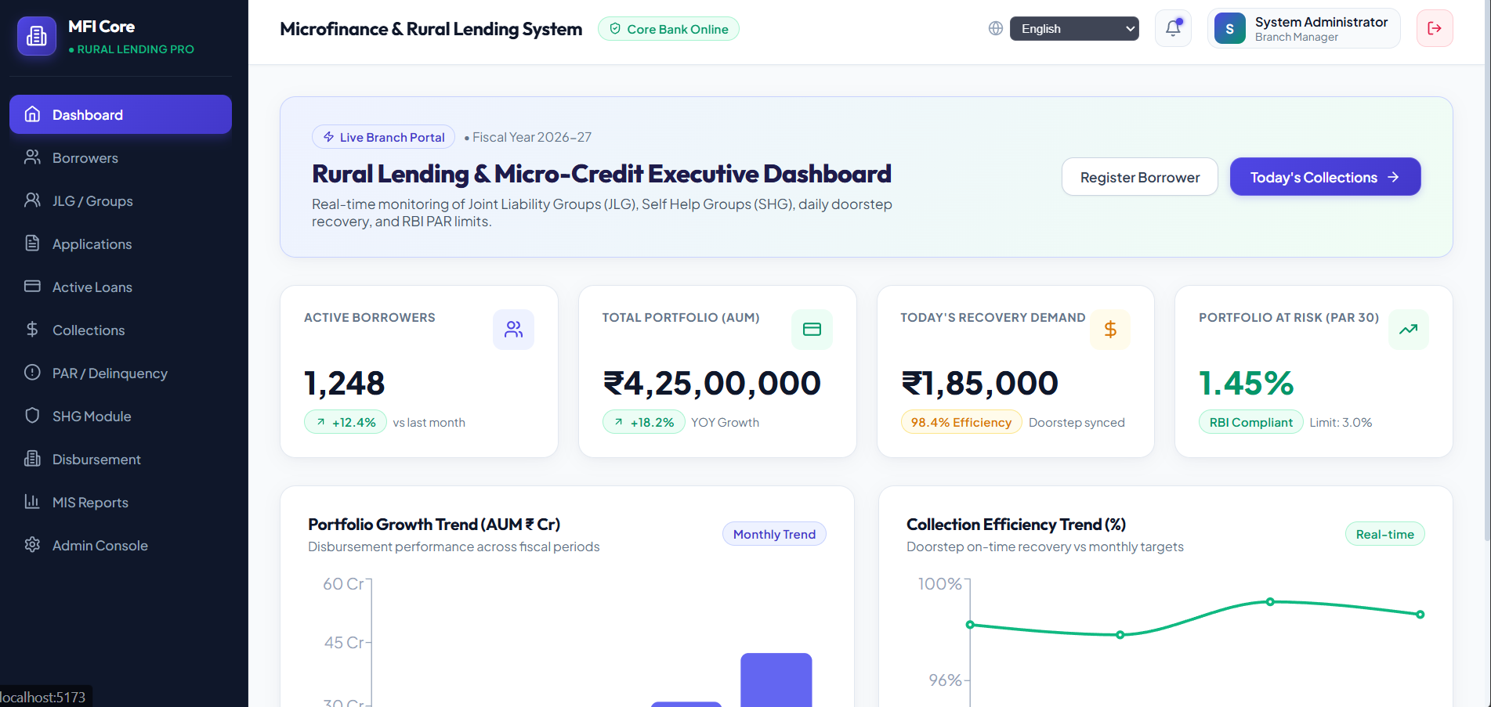
Figure 2: Multi-Lingual Gold Standard Branch Portal Terminal
Demonstration of the rural branch terminal equipped with full vernacular language localization. Field officers and branch managers can seamlessly toggle between English, Hindi (हिंदी), Tamil (தமிழ்), Telugu (తెలుగు), and Kannada (ಕನ್ನಡ), empowering localized doorstep banking operations.
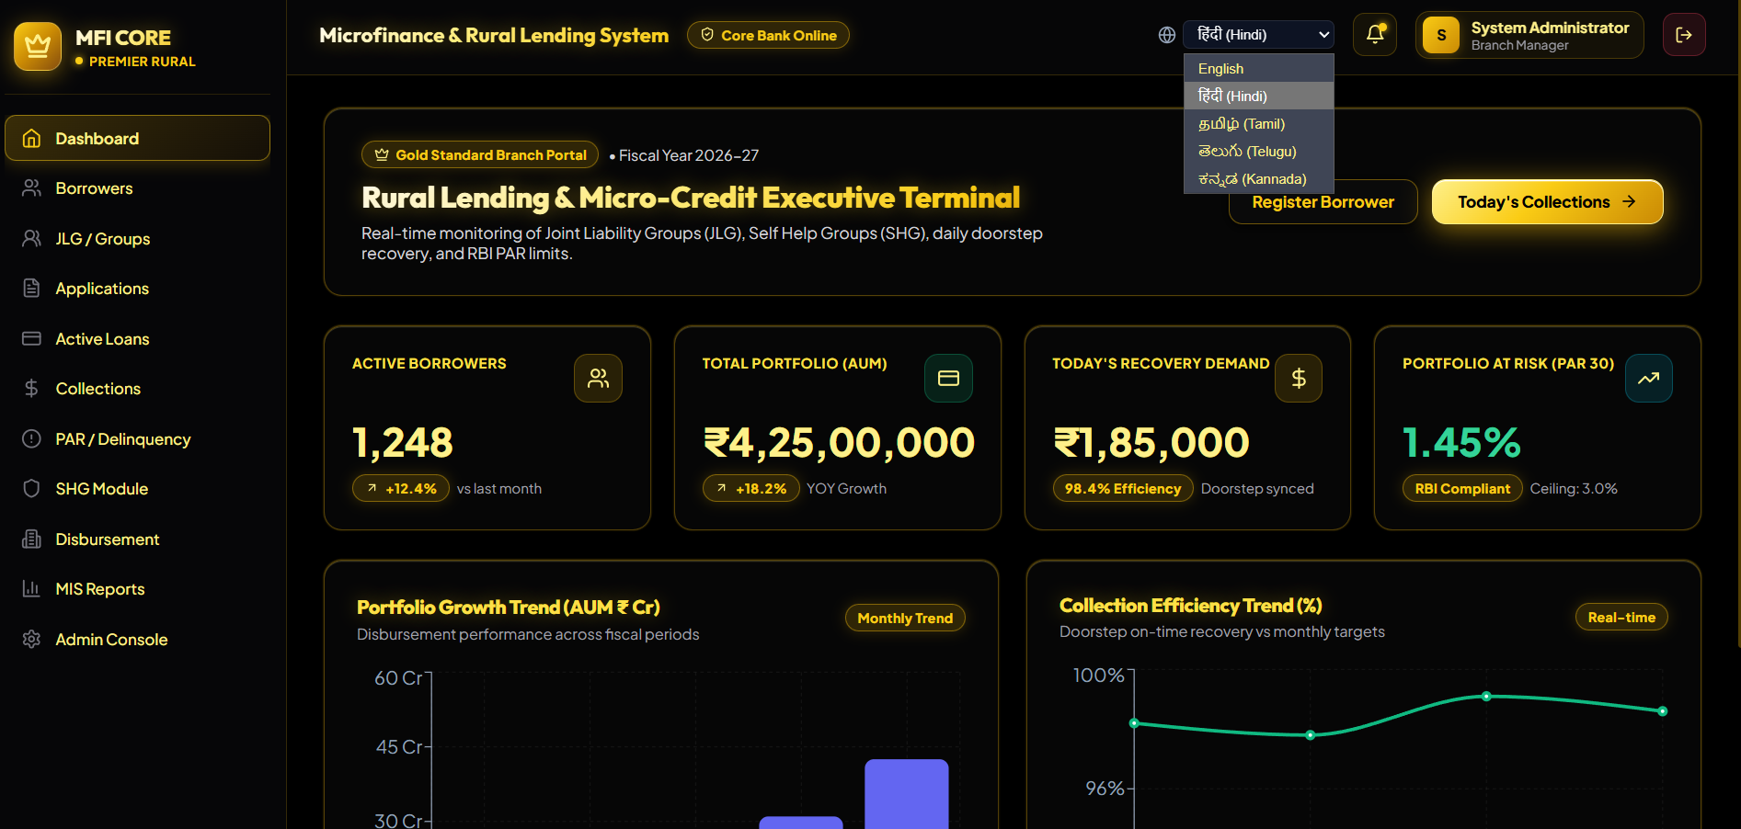
Figure 3: Real-Time Audit Stream & RBI PAR-30 Compliance Feed
The live event feed displays immediate audit telemetry across banking operations. Recent activity includes automated biometric e-KYC clearance for borrower Radha Yadav (BRN-VAR-1003) and real-time validation confirming that portfolio risk (PAR-30) is maintained safely at 1.45% against the 3.00% ceiling.
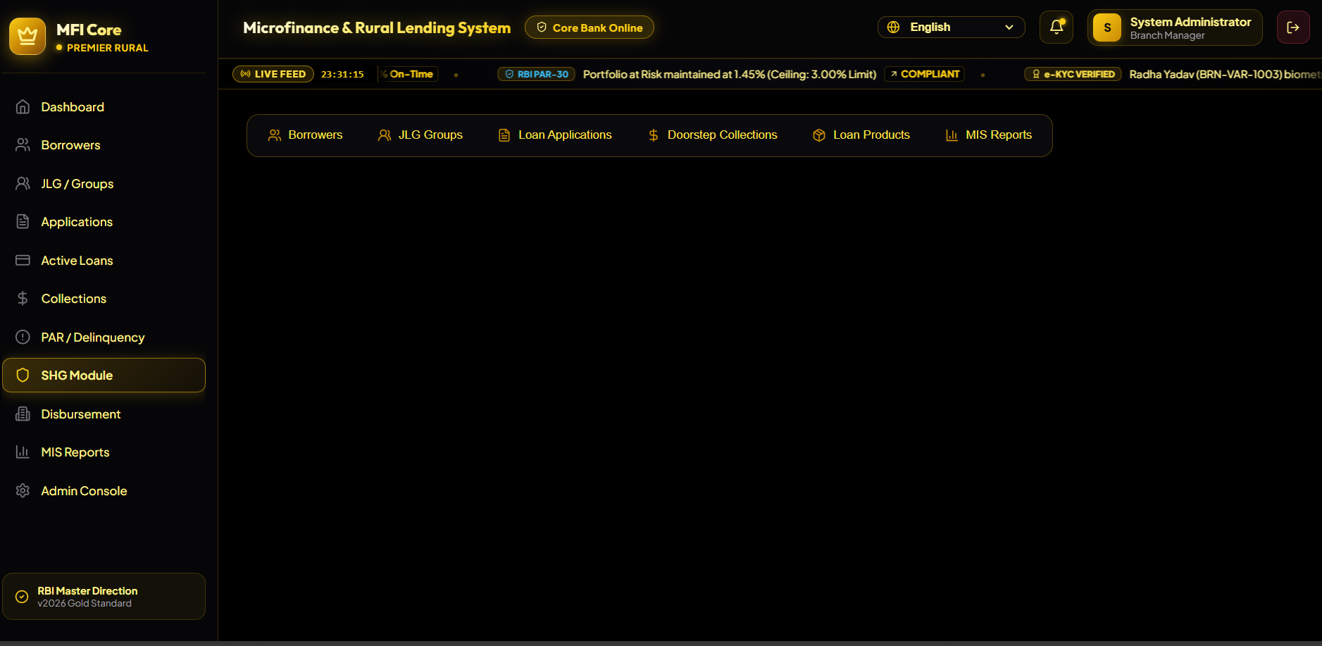
Figure 4: Doorstep Field Operations & Village Center Meeting Synchronization
Real-time synchronization status panel reflecting field operations. Field Officer Vikram Singh has completed 18 village doorstep center meetings in Shivpur, achieving a 99.2% offline-to-online transaction sync rate and 100% KYC clearance across group loan collections.
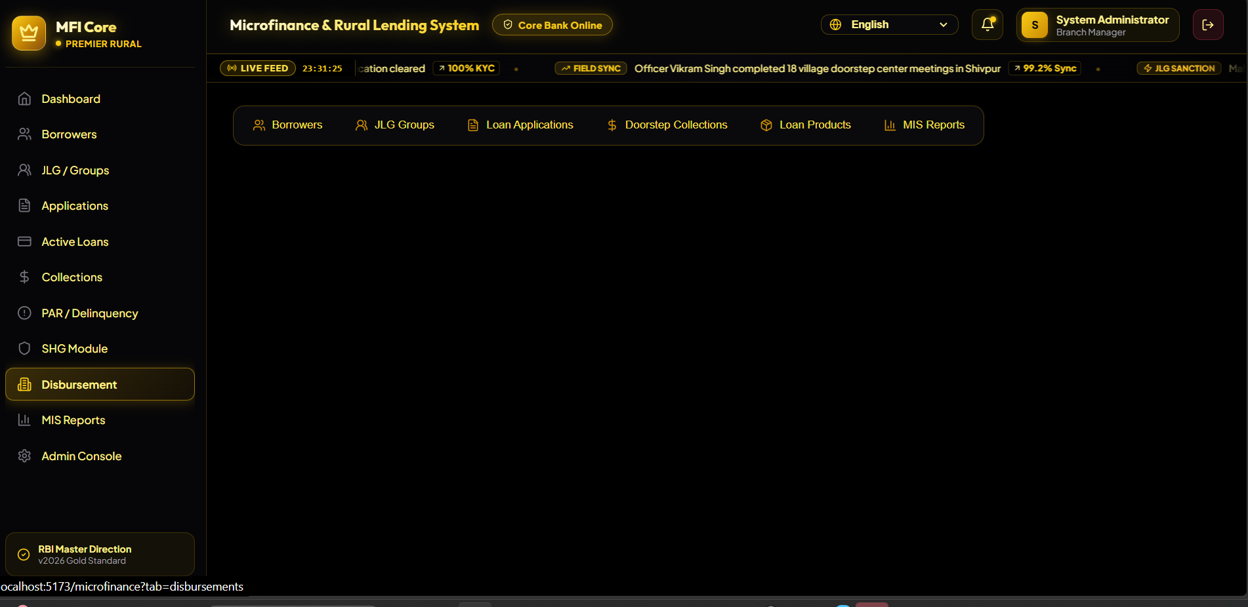
Figure 5: Rural Borrower Registration & KYC Directory Management
Borrower enrollment workflow showing the comprehensive KYC registration form (Name, 10-digit Mobile, 12-digit Aadhaar, Village, and Annual Household Income). The lower grid displays the registered borrowers directory with unique Borrower Reference Numbers (BRN-VAR-2026-1001), demographic details, and verified KYC badges.
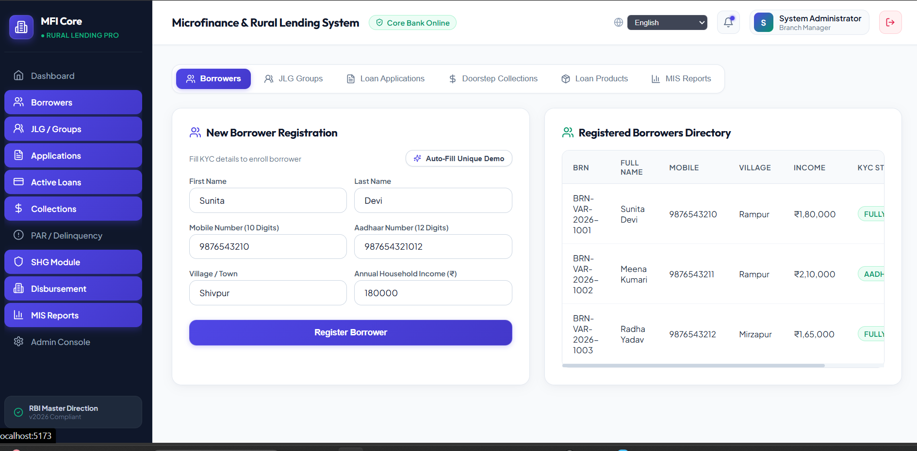
Figure 6: Digital Loan Application Processing & End-Use Purpose Selection
Digital credit origination interface capturing requested principal loan amount (₹30,000), repayment tenure (12 Months), and productive rural end-use purpose category (Dairy Farm & Cattle Feed Purchase) with automated repayment schedule projection.
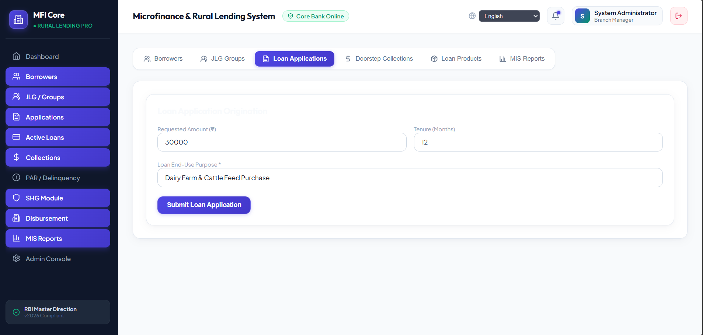
Figure 7: Self-Help Group (SHG) Module & Jai Santoshi Maa Group Registration
Self-Help Group (SHG) federation dashboard tracking 84 active groups, 1,120 women members, +14.8% thrift savings growth, and NRLM bank linkage facilities with a 94.5% Grade A Panchasutra rating. The modal confirms successful registration of "Jai Santoshi Maa SHG" with 12 initial members.
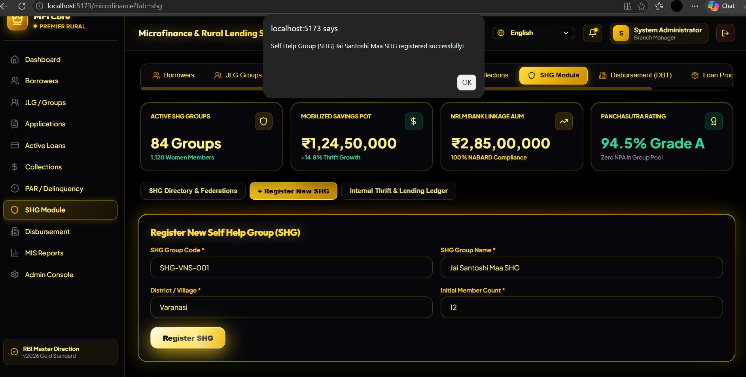
Figure 8: System Administration Console & Role-Based Access Control (RBAC)
Centralized system administration console managing staff user accounts, role definitions (ADMIN, BRANCH_MANAGER, FIELD_OFFICER), branch assignments (Head Office, Varanasi Main Branch), and real-time active status controls.
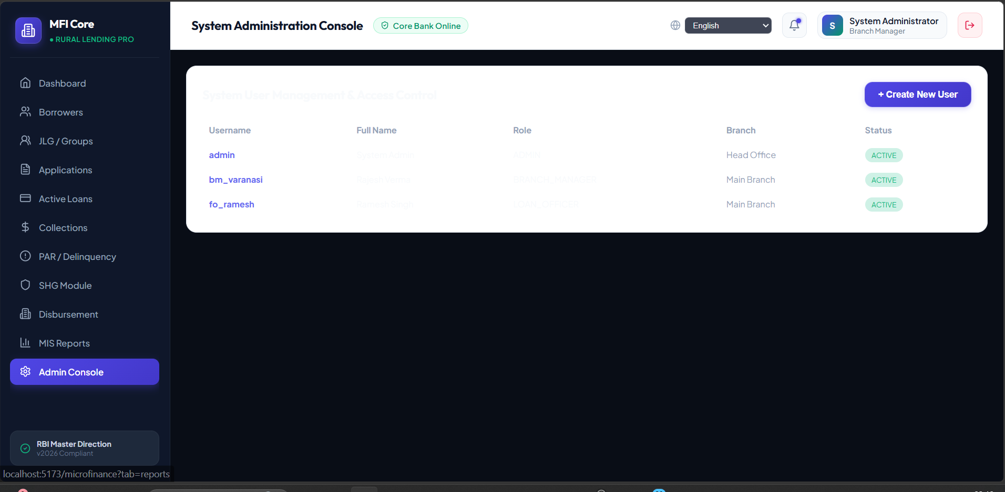
Figure 9: Portfolio at Risk (PAR-30 / Delinquency) & NPA Recovery Tracker
Delinquency management navigation view displaying loan repayment status, overdue aging buckets, doorstep recovery tracking, and branch-level PAR performance.
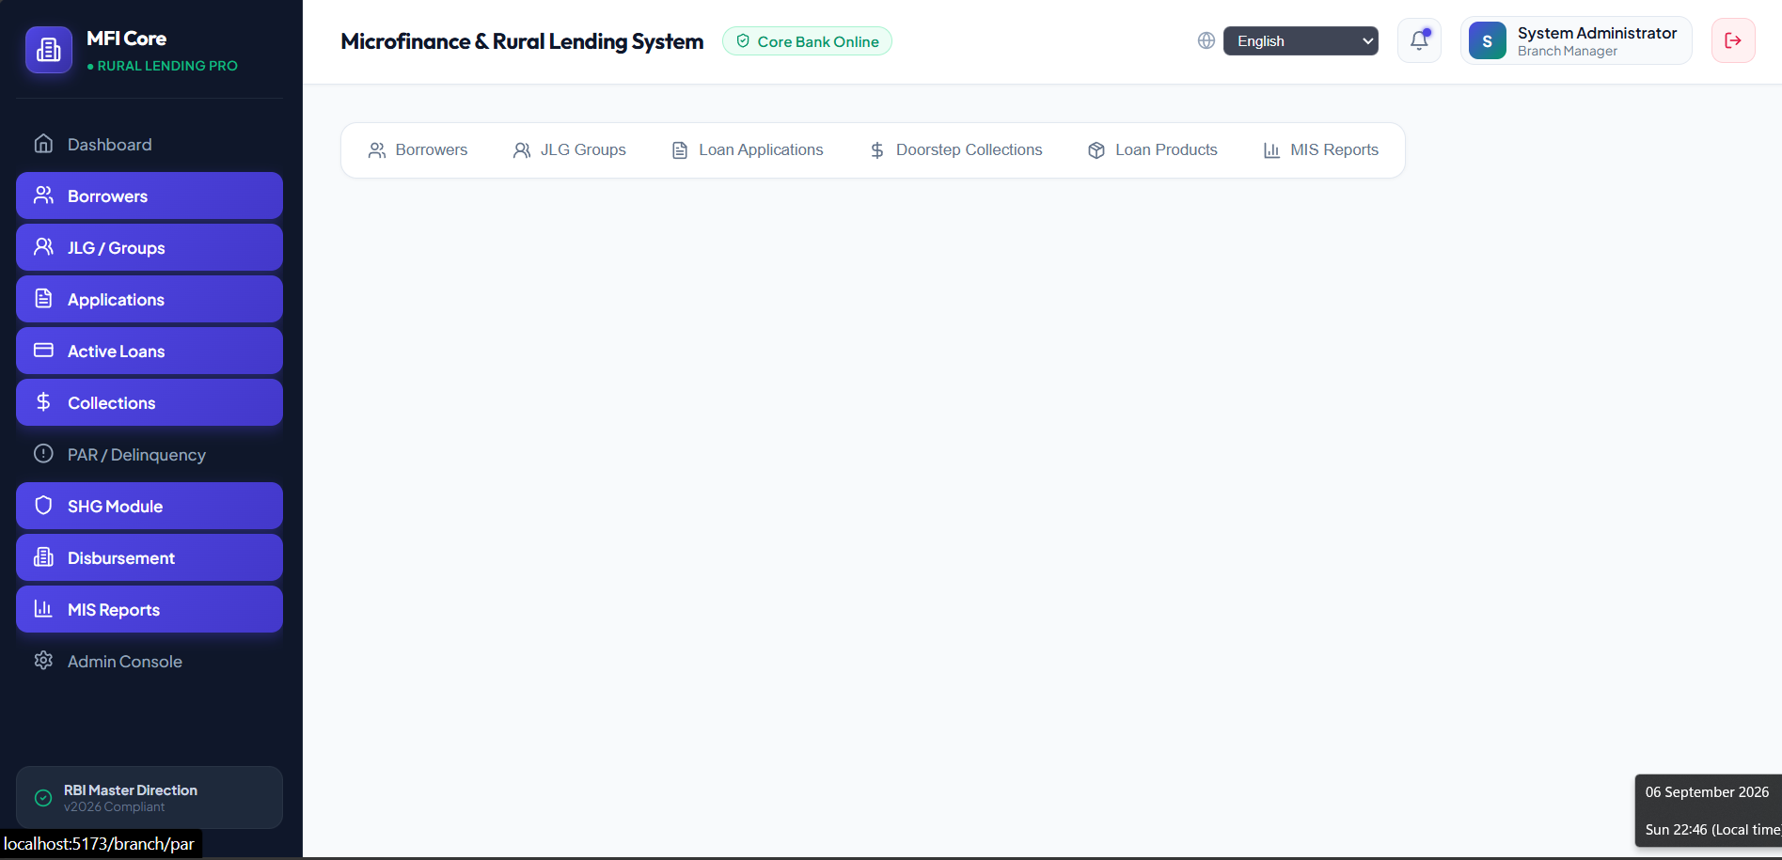
MYSQL DATABASE OUTPUT
DATABASE TABLES SCHEMA (microfinance_db)
List of 16 core banking relational tables generated and managed by Hibernate DDL in the MySQL database:
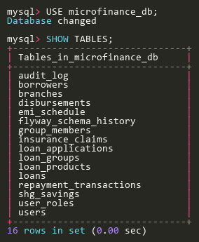
REGISTERED SYSTEM USERS QUERY (SELECT * FROM users)
Active user accounts with mapped designations, roles, and status verification:
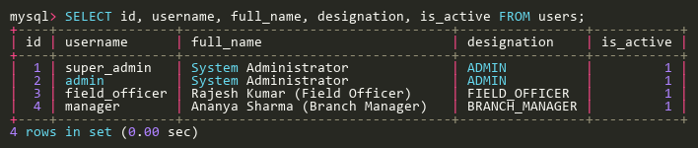
REGISTERED RURAL BORROWERS QUERY (SELECT * FROM borrowers)
Sample verified borrower records stored in MySQL table with KYC status:


